6 August 2020
[131-20]

Supporting document 1

Risk assessment – Application A1180

Natural Glycolipids as a preservative in non-alcoholic beverages

Executive summary
LANXESS Deutschland GmbH has applied to change the Australia New Zealand Food Standards Code to permit the use of long-chain glycolipids, obtained through the fermentation of glucose by the edible jelly mushroom Dacryopinax spathularia, as a preservative in non-alcoholic beverages. The application is seeking permission for jelly mushroom glycolipids at levels ranging between 2 to 100 mg/kg for different non-alcoholic beverage categories.

The applicant established the identity of the production organism using a combination of morphological, molecular phylogenetic and chemotaxonomic methodologies. Morphological characteristics and secondary chemical metabolites of the production organism were confirmed against an authentic strain of D. spathularia.

The submitted data, together with information located from other sources, are considered suitable to assess the efficacy of jelly mushroom glycolipids. The exact mechanism for the mode of action for glycolipids has not been established. However, the results of in vitro studies suggest that the surfactant properties of glycolipids alter the cytoplasmic membrane leading to increased permeability. The metabolism of the cells is affected leading to cell death. Results of in vitro studies suggest that there are important differences in the response of microorganisms to jelly mushroom glycolipids. Gram-negative bacteria are the most resistant, followed by Gram-positive bacteria. Challenge studies using defined mixtures of yeasts and moulds highlighted differences between non-alcoholic beverage types.

Pharmacokinetic data for radiolabelled jelly mushroom glycolipids and their major hydrolysis products indicate that both the parent mixture and the hydrolysis products are likely to be poorly absorbed by the oral route. There was no evidence of persistence or bioaccumulation in any particular tissue. Acute oral toxicity in rats was greater than 2000 mg/kg bw.

In a 90-day Good Laboratory Practice (GLP)-compliant drinking water study in Sprague Dawley rats, no adverse effects were found at the highest dose administered, equivalent to 1201 and 1423 mg/kg bw/day in male and female rats, respectively. In a 90-day GLP-compliant oral capsule study in Beagle dogs, a significant reduction, relative to that of controls, in group mean cumulative bodyweight gain in female dogs, with a corresponding but non-significant reduction in group mean food consumption, at 1000 mg/kg bw/day, is considered to be adverse by FSANZ. FSANZ considers that the No Observed Adverse Effect Level (NOAEL) for this study is 500 mg/kg bw/day.

No chronic or carcinogenicity studies of jelly mushroom glycolipids were submitted or located by literature search. Jelly mushroom glycolipids were not genotoxic in GLP-compliant genotoxicity studies. There was an absence of test article-related lesions in the repeat-dose studies, and therefore there was no evidence of neoplastic potential by a non-genotoxic mechanism.

Potential for developmental and/or reproductive toxicity was assessed in two GLP-compliant studies in Sprague Dawley rats, a developmental toxicity study and a two-generation reproductive toxicity study. The No Observed Adverse Effect Level (NOAEL) for parental toxicity, embryo/fetal developmental toxicity and toxicity to offspring was the highest dose tested in the two studies, 1000 mg/kg bw/day.

No human tolerance studies of jelly mushroom glycolipids were submitted or located. Dacryopinax spathularia is listed in the FAO compendium on edible mushrooms and is described as edible in peer-reviewed publications from a range of countries in multiple continents. There are no case reports of allergic reactions to the source organism, or evidence of allergenic potential of jelly mushroom glycolipids, or glycolipids generally.

The ADI is derived from the lowest NOAEL identified in animals, 500 mg/kg bw/day in Beagle dogs. FSANZ has applied an uncertainty factor of 10 for extrapolation from animals to humans, an uncertainty factor of 10 for variability between humans, and an uncertainty factor of 3 allowing for extrapolation from a subchronic study to chronic exposure, for a total uncertainty factor of 300. An uncertainty factor of 3, rather than 10, has been selected because there is a clear NOAEL at 500 mg/kg bw/day, and the effect is minimal at twice that value, although the dogs were at an age when growth is rapid and energy requirement is high. The ADI is established by division of the lowest NOAEL (500 mg/kg bw/day) by the total UF (300), approximately equalling 1.6, and rounded to 2.0 mg/kg bw/day.

The dietary exposure assessment for jelly mushroom glycolipids assessed additive uses only across three scenarios; General Maximum Permitted Level (MPL), Specific MPL and Usual Use levels and for three population groups; Australians aged 2 years and above, New Zealanders aged 15 years and above and New Zealand children aged 5-14 years. The assessment showed that mean and 90th percentile (P90) estimated dietary exposures for all scenarios and population groups assessed fell below the ADI of 2.0 mg/kg bw/day. The mean dietary exposures ranged between 9-35% of the ADI and P90 dietary exposures ranged between 20-75% of the ADI.

Across all population groups assessed and across all scenarios, the top two major contributing food categories to jelly mushroom glycolipids dietary exposures were: 1) Water based flavoured drinks, excluding powders, iced teas, brewed soft drinks; and 2) Fruit and vegetable juices.

Based on the safety and dietary exposure assessments, there is no evidence of a public health and safety concern associated with the use of jelly mushroom glycolipids at the proposed used levels in non-alcoholic beverages, based on an ADI of 2.0 mg/kg bw/day.

Table of contents
Executive summary i
1 Introduction 4
1.1 Objectives of the assessment 4
2 Food Technology assessment 4
2.1 Chemical names, identification and structure 4
2.2 Manufacturing process 5
2.3 Purity 6
2.4 Stability 7
2.5 Technological function 7
2.6 Methods of analysis in beverages 7
2.7 Food technology conclusion 7
3 Efficacy of Glycolipid mixture (AM-1) 8
3.1 Mode of action and minimum inhibitory concentrations 8
3.2 Challenge study 9
3.3 Discussion and conclusion 10
4 Safety assessment 11
4.1 Background 11
4.1.1 Evaluation of the submitted data 11
4.1.2 Characteristics of jelly mushroom glycolipids 11
4.2 Toxicological Data 11
4.2.1 Identity and history of safe use 11
4.2.2 Toxicokinetics and metabolism 12
4.2.3 Acute toxicity studies in animals 13
4.2.4 Short-term toxicity studies in animals 14
4.2.5 Long-term studies/carcinogenicity in animals 17
4.2.6 Genotoxicity assays 17
4.2.7 Developmental and reproductive toxicity studies in animals 19
4.2.8 Special studies 22
4.2.9 Human tolerance studies 22
4.2.10 Human allergenic potential 22
4.3 Assessments by other regulatory agencies 22
4.4 Discussion and conclusion 23
5 Dietary Exposure assessment 24
5.1 Jelly mushroom glycolipids in other foods 24
5.2 Proposed concentrations of jelly mushroom glycolipids as a food additive in foods 26
5.3 Food consumption data used 27
5.4 Population groups assessed 31
5.5 Estimated dietary exposures to jelly mushroom glycolipids 31
5.6 Major contributing foods to jelly mushroom glycolipids dietary exposure 34
5.7 Risk Characterisation 36
5.8 Summary of Dietary Exposure Assessment Results 37
6 References 38
Appendix 1: Dietary Exposure Assessments at FSANZ 41
A.1.1 How the estimated dietary exposures were calculated 41
A1.2 Food consumption data used 41
A1.3 Assumptions and limitations of the dietary exposure assessment 42

1 Introduction
An Application received from LANXESS Deutschland GmbH seeks permission to use a mixture of long-chain glycolipids derived from an edible jelly fungus (Dacryopinax spathularia) as a preservative in non-alcoholic beverages. This Glycolipid mixture is commonly referred to as “jelly mushroom glycolipids”. The glycolipid mixture has anti-fungal properties against common yeasts and moulds. The applicant considers jelly mushroom glycolipids useful in preventing microbiological spoilage of beverages.

Objectives of the assessment
The objective of this assessment is to determine whether the jelly mushroom glycolipids meet the described technological function as a preservative in non-alcoholic beverages. The assessment also seeks to determine whether AM-1(the manufacturers technical term for the glycolipid mixture) is safe for human consumption, and whether there are any potential public health and safety issues with AM-1 when added to non-alcoholic beverages.

2 Food Technology assessment

2.1 Chemical names, identification and structure
Table 1: Detail of jelly mushroom glycolipids identity
Common Names | ‘Jelly mushroom glycolipids’ or ‘Natural Glycolipids’
Other Names | ‘long-chain glycolipids from Dacryopinax spathularia’ or ‘NagardoTM’
C.A.S registry number | 2205009-17-0
Physical Properties | Off-white ivory powder with a weak characteristic odour
Aqueous solubility | > 20 g/L
Turbidity (0.1% in water) | < 8 NTU
NTU = Nephelometric Turbidity Unit

The major components of the glycolipid mixture (AM-1) are three structurally-related
glycolipid congeners. Representative structure diagrams for these main components (i, ii, iii) are provided in Figure 1.

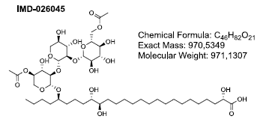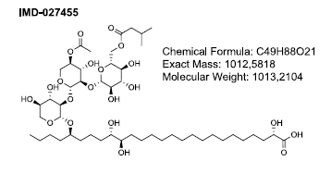
i)
iii)
C₄₉H₈₈O₂₁
MW: 1012 Da
C₄₆H₈₂O₂₁
MW: 970 Da
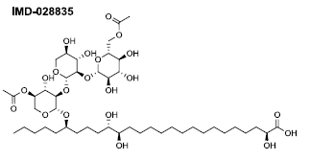
ii)
C₄₆H₈₂O₂₁
MW: 970 Da
Figure 1 Structural formulas and Molecular weights of jelly mushroom glycolipids

2.2 Manufacturing process
The jelly mushroom glycolipids are obtained through the fermentation of glucose by the edible jelly fungus Dacryopinax spathularia. This fungus is commonly known as sweet osmanthus ear. It belongs to the phylum Basidiomycota and builds edible orange coloured spatula-shaped fruiting bodies.

Fermentation of Dacryopinax spathularia strain MUCL 53181 is conducted using glucose as carbon source in aerobic submerged culture. Starting from a cryogenic Working Cell Bank, a series of seed cultures is conducted in shake flasks and then in bioreactors with increasing volumes in order to obtain sufficient living fungal cells to inoculate the main culture. The main culture is conducted in fed-batch mode, with start medium and feed medium both consisting of glucose and smaller amounts of yeast extract (commercial extract of autolysed Baker’s yeast Saccharomyces cerevisiae). The culture is maintained at 30 °C for several days until the maximum titre of glycolipids is achieved. The feed is stopped and the cells are further cultivated until no free glucose is found in the culture medium.

The fungal cells are then quantitatively removed by microfiltration, followed by acidic precipitation of the glycolipids. The absence of any remaining intact fungal cells from the source organism Dacryopinax spathularia is technically excluded by the design of the microfiltration step and has been confirmed by viable fungal cell count as well as microscopic control of representative batches. The precipitate is washed with water and neutralized using sodium hydroxide solution. Spray or freeze drying leads to the final product as an off-white/ivory, water soluble powder.

Nutrient media used in the fermentation process contain glucose and yeast extract. Hydrochloric acid and sodium hydroxide solution are used for pH adjustment during downstream processing. All nutrient components and solutions for pH adjustment are food-grade. The simple production process consists only of typical food-grade processing steps. No organic solvents are used. No chemical reaction or modification of the glycolipids is done. A manufacturing process flow diagram is provided Error! Reference source not found. in Figure 2.

Filtrate
Cell mass
Waste
Precipitation
Wash with water
Neutralization
Final Product
Remove cells (microfiltration)
Spray drying
1) Fermentation process: 2) Downstream process:
Fermentation broth
Master cell bank
Seed culture 1
Seed culture 2
Seed culture 3
Main culture

Figure 2 Manufacturing process flow diagram for jelly mushroom glycolipids

2.3 Purity
The following table outlines the purity profile of the AM-1 and the analysis methods used for each analytical parameter.

Table 2: Purity profile of the jelly mushroom glycolipids

Analytical Parameter | Acceptable Target/Range
pH value (1% in water) | 5.0 – 7.0
Water content | < 5.0%
Total protein | < 3.0%
Total fat | < 2.0%
Sodium | 1.7 – 3.3%
Total glycolipids (dry weight basis, calc. as sodium salt) | ≥ 93.0%
Heavy metals | < 1 mg/kg As  < 1 mg/kg Cd  < 1 mg/kg Hg  < 2 mg/kg Ni  < 2 mg/kg Pb
TAMC (total aerial microbial count) | ≤100 CFU/g
TYMC (total yeast/mould count) | ≤10 CFU/g
Coliforms | ≤ 3 MPN/g
Escherichia coli | ≤ 3 MPN/g
Salmonella species | absent in 25 g

2.4 Stability
When stored in dry powder form at 40°C and below in a closed container, AM-1 has been shown to be stable for at least three years (Bitzer, 2016). When stored in an aqueous solution, AM-1 is stable at room temperature for at least six months. There is a minor level (<5%) of hydrolysis that occurs to AM-1. The antimicrobial effects of AM-1 do not appear to be impacted by hydrolysis (Lanxess, 2018).

The glycolipid mixture AM-1 was tested in 110 varying commercial beverages including carbonated soft drinks, fruit drinks, enhanced waters, sports drinks, energy drinks, syrups and ready to drink tea. Beverages were stored for 3 months at ambient temperature. It was found through high performance liquid chromatography-mass spectrometry (HPLC-MS) analysis there was no degradation of the glycolipids to their principal components of glucose, xylose and long-chain fatty acids in any beverage (Lanxess, 2018).

The acidity (pH) level of beverages was found to influence some degree of hydrolysis similar to the previously mentioned storage of AM-1 in an aqueous solution (Lanxess, 2018). Lower pH values of beverages (<3 pH) were found to result in greater levels of hydrolysis resulting in a higher ratio of decaylated glycolipids present in the beverages. Beverages with a pH >3.5 showed only low degrees of hydrolysis.

2.5 Technological function
The jelly mushroom glycolipids are intended to be used as preservative to prevent microbial spoilage in non-alcoholic beverages. It is to be added to beverages immediately prior to packaging, in a similar manner to existing preservatives.

The jelly mushroom glycolipids are reported to have an antifungal effect against common yeasts, moulds and antimicrobial effect against bacteria, making it a preservative to prevent microbiological spoilage of non-alcoholic beverages. The jelly mushroom glycolipid mixture is considered to prolong shelf life and can help guarantee the microbiological quality of beverages, making them an alternative or complement to other preservation techniques such as heat treatment (Lanxess, 2018a).

2.6 Methods of analysis in beverages
Jelly mushroom glycolipids can be detected and quantified in beverages by HPLC-MS. Mass spectrometry as a sensitive method of analysis also assures high selectivity for jelly mushroom glycolipids, independent from the beverage matrix by focusing on the relevant molecular weights only (Bitzer, 2016).

2.7 Food technology conclusion
FSANZ concludes that the use of jelly mushroom glycolipids when used as a food additive for preservative purposes is justified. It may serve as an alternative to existing permitted preservatives, or be used in addition to non-alcoholic beverage production methods used to reduce spoilage from yeasts, moulds and bacteria. There is currently no specification for jelly mushroom glycolipids in the Food Standards Code. As such, a proposed specification based on the identification and purity data reviewed by FSANZ is provided in the Call For Submissions report associated with this application.

3 Efficacy of Glycolipid mixture (AM-1)

3.1 Mode of action and minimum inhibitory concentrations
The applicant seeks permission to use a mixture of long-chain glycolipids derived from an edible jelly fungus (Dacryopinax spathularia) as a preservative in non-alcoholic beverages. A range of microorganisms, notably yeasts and moulds, can cause spoilage of non-alcoholic beverages due to their ability to grow at low pH and high sugar concentrations. Resistance to preservatives such as sorbic acid and benzoic acid are important for shelf-life of fruit juices and other beverages (Tribst et al, 2009). Spoilage yeasts include species from the Saccharomyces, Zygosaccharomyces, Candida and Dekkera genera. Typical spoilage moulds in beverages include the genera Penicillium, Aspergillus and Brettanomyces. Heat resistant mould spores of Byssochlamys, its anamorphic (asexual) stages Paecilomyces, and Neosartorya spp. can survive pasteurization. This can result in spoilage of hot-filled products, including carbonated beverages, sport drinks, and teas. Bacteria, such as Bacillus cereus or certain lactic acid bacteria are also known to spoil beverages.

The exact mechanism for the mode of action for glycolipids has not been established. The results of in vitro studies suggest that the surfactant properties of glycolipids alters the cytoplasmic membrane leading to increased permeability and leakage of cell contents. The metabolism of the cells is affected (e.g. inhibition of acid production from glucose) and cell death.

Kulakovskaya et al. (2003) treated cells of Saccharomyces cerevisiae yeast with purified glycolipids produced by Pseudozyma fusiformata. Susceptible yeast cells were found to leak ATP (adenosine triphosphate) due to enhanced non-specific permeability of the cytoplasmic membrane. Sotirova et al (2008) measured the effects of cell permeability of a complex mix of glycolipids and a biopolymer isolated from a bacterial Pseudomonas species. Three bacterial species were tested: Gram-positive Bacillus subtilis and two Gram-negative species, Escherichia coli and Pseudomonas aeruginosa. The study found that the test mixture was more effective as measured by the leakage of protein and inhibition of growth, against the Gram-positive B. subtilis, compared with the Gram-negative species. Mimee (2009) studied the antibacterial activity produced by Pseudozyma flocculosa on a range of Gram-positive bacteria (n = 9) including Bacteroides spp., E. coli and Pseudomonas putida and Gram-negative bacteria (n = 36) including Bacillus spp., Clostridium spp., Leuconostoc spp. and Staphylocccus spp. Consistent with other studies, the Gram-positive bacteria were more sensitive, as indicated by lower Minimum Inhibitory Concentrations (MICs) compared to the Gram-negative strains. Additional studies into the activity of the glycolipid on the yeast, Candida albicans, found a rapid and dose dependent loss of cell viability, inhibition of acid production from glucose and leakage of cellular potassium. A 99% reduction in cell concentration was observed within 3 hours at the MIC of 25 mg/l.

A study provided by the applicant provides a comparison of MICs for a wide range of Gram-positive bacteria (including Bacillus spp., Clostridium spp. and lactic acid bacteria), yeasts (Aspergillus spp., Byssochlamys, Talaromyces and Dekkera spp.) and moulds (Saccharomyces, Zygosaccharomyces spp. and Candida). A graphical summary of the MICs for each group of microorganisms is in Figure 3. The median MICs for Gram-positive bacteria, yeasts and moulds are 25, 6.3 and 9.4 mg/l, respectively. The variability in the MICs for the Gram-positive bacteria species is greater than for both the yeasts and moulds species tested. This suggests that the AM-1 glycolipid mixture may be best suited to control yeasts and moulds in beverages, rather than Gram-positive or Gram-negative bacteria (Sotirova et al, 2008; Mimee et al, 2009).

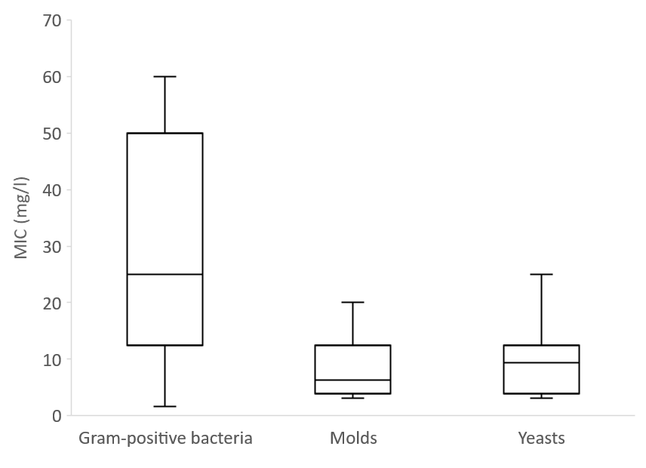
Figure 3 MIC values (mg/l) of jelly mushroom glycolipids (AM-1) against Gram-positive spoilage bacteria, yeasts, and moulds in Orange Serum Agar (OSA) and malt extract glucose media

3.2 Challenge study
Additional data provided by the applicant concerned challenge studies for the AM-1 glycolipid mixture in commercially produced non-alcoholic beverages. Challenge studies were performed using defined mixtures of yeasts (Saccharomyces cerevisiae, Zygosaccharomyces rouxii and Zygosaccharomyces bailii) or molds (Aspergillus brasiliensis, Byssochlamys nivea and Penicillium roqueforti) in 150 commercially available non-alcoholic beverages.

The AM-1 was added to the nonpreserved beverages, usually as a certain volume of a 10 mg/l stock solution in water. The beverage was mixed thoroughly to assure homogenous dissolution of AM-1. Then the test organisms were added either as yeast mixture or mould mixture. In both cases, the initial inoculum was ca. 100 cfu/ml as proven by viable cell counts at test start. Incubation of test and growth controls (i.e. the non-preserved beverage) was done at ambient temperature for three months.

For flasks, tests were carried out in the original container without protection from light. In the case of cans, Tetra-Pak® or other non-closable containers, the beverages were filled into sterile glass bottles before the start of the test and protected against light during the test, as would have been the case in the original container. Readout was done visually on a regular basis and – after three months – by determination of the viable cell count (cfu/ml) using the spread or pour plate method with Sabouraud Dextrose Broth (SDB) or OSA agar.

Results suggest that the minimum effective concentration of AM-1 depends on the nature of the beverage, including juice content and turbidity (summarized in Figure 4). The lowest use levels for the commercially available non-alcoholic beverages were found for clear fruit drinks (3 – 5 mg/l), with the highest levels in beverages containing turbid juices (up to 100 mg/l).

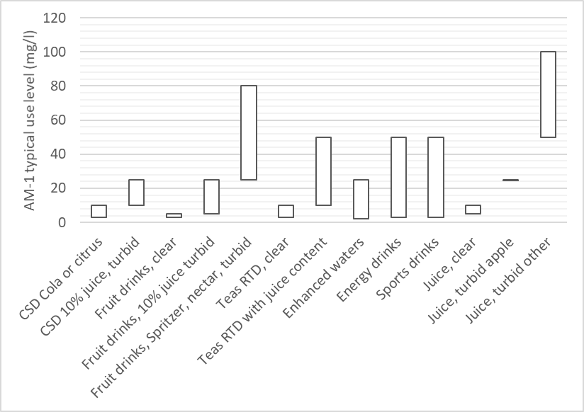
CSD = Carbonated soft drinks

Figure 4 Typical AM-1 use levels in different beverage types based on yeast and mould challenge studies.

3.3 Discussion and conclusion
The submitted data, together with information located from other sources, are considered suitable to assess the efficacy of jelly mushroom glycolipids.

Results of in vitro studies suggest that there are important differences in the response of microorganisms to jelly mushroom glycolipids. Gram-negative bacteria are the most resistant, followed by Gram-positive bacteria. Yeast and moulds are the least resistant of the microorganisms, based on measured MICs.

The exact mechanism for the mode of action for glycolipids has not been established. The results of in vitro studies suggest that the surfactant properties glycolipids alters the cytoplasmic membrane leading to increased permeability and leakage of cell contents. The metabolism of the cells is affected (e.g. inhibition of acid production from glucose) and cell death.

Challenge studies using defined mixtures of yeasts and moulds highlighted differences between non-alcoholic beverage types.

FSANZ concludes that the addition of jelly mushroom glycolipids at the proposed use levels is effective as a preservative against yeasts and moulds in non-alcoholic beverages.

4 Safety assessment

4.1 Background

4.1.1 Evaluation of the submitted data
FSANZ has assessed the submitted evidence on the safety of jelly mushroom glycolipids and information from other sources. The assessed data included information on toxicokinetics and metabolism, genotoxicity, and toxicity in laboratory animals. The submitted data are considered suitable to assess the hazard of jelly mushroom glycolipids.

4.1.2 Characteristics of jelly mushroom glycolipids
The chemical characteristics of jelly mushroom glycolipids are discussed in detail in Section 2. Jelly mushroom glycolipids are a glycolipid mixture obtained via fermentation of glucose by the edible jelly fungus Dacryopinax spathularia. Other substances that may be present in small amounts include proteins, lipids, and sodium chloride.

4.2 Toxicological Data

4.2.1 Identity and history of safe use
The applicant established the identity of the organism using a combination of morphological, molecular phylogenetic and chemotaxonomic methodologies. Morphological characteristics and secondary chemical metabolites of MUCL 53181 were confirmed against an authentic strain of D. spathularia, CBS 197.63 obtained from the Centrallbureau voor Schimmelcultures (CBS), Utrecht in The Netherlands. Molecular phylogenetic identification against CBS 197.63 was performed using large subunit ribosomal DNA (LSU rDNA) sequencing. The two sequences had a 98% identity. A phylogenetic tree analysis determined that MUCL 53181 clustered with CBS 197.63 strain and other sequences of Dacrymycetaceae from public databases. This result was independently confirmed using the NCBI (National Center for Biotechnology Information) Blast (Basic Local Alignment Search Tool) Nucleotide Sequence database, Figure 5 as Query_19021. D. spathularia MUCL 53181 has been deposited at the Mycothèque de l'Université Catholique de Louvain in Belgium, under the designation number MUCL 53181.

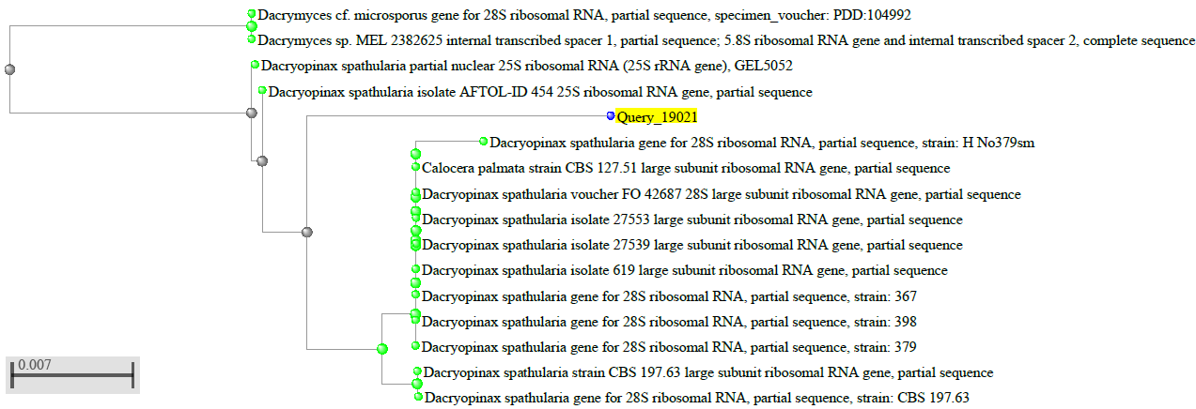

Figure 5 Phylogenetic tree for Dacryopinax spathularia using NCBI BLAST Nucleotide sequence database

Dacryopinax spathularia is listed in the Food and Agriculture Organization of the United Nations (FAO) compendium on edible mushrooms (Boa 2004). It is described as edible in peer-reviewed publications from a range of countries including Rwanda, Burundi (Degreef et al 2016), Cameroon (VanDijk et al 2003; Onguene and Kuyper 2019), India (Ao et al 2016; Kumar et al 2018, 2019), China (Zhishu et al 1993), Malaysia (Lee et al 2009), the USA (Meuninck 2017) and Ecuador (Gamboa-Trujillo et al 2019).

4.2.2 Toxicokinetics and metabolism
Pharmacokinetic study of radiolabelled glycolipids from Dacryopinax spathularia in rats (Charles River Laboratories 2017; Bitzer et al 2017a) Regulatory status: GLP; conducted in accordance with FDA Redbook II Guidelines, Chapter V.B

The test articles for this study were the commercial product that is the subject of the application, which was called AM-1 in the study report and subsequent publication in Food and Chemical Toxicology, and a mixture of long chain fatty acids (LCFA) that comprises the major hydrolysis product of AM-1. The study sponsor supplied both non-radiolabelled and radiolabelled AM-1, and also provided non-radiolabelled and radiolabelled versions of LCFA. Purity of the non-radiolabelled test articles was not specifically stated, but test article information and dose formulation calculations included in the study report indicate that it was close to 100%. The radiolabel, ¹⁴C, was evenly distributed within the mixtures of glycolipids in AM-1 and the long-chain fatty acids produced from them in LCFA. Radiochemical purity was 100% for both AM-1 and LCFA. For oral administration, dose formulations of both AM-1 and LCFA were prepared and administered as fine suspensions in physiological saline containing 0.5% methylcellulose. For intravenous administration, radiolabelled AM-1 or LCFA were dissolved in DMSO and extended with PEG400. Dose analysis of the radiolabelled dose formulations was conducted using liquid scintillation counting (LSC) and radio-high performance liquid chromatography (HPLC), and dose analysis of the non-radiolabelled dose formulations was conducted using high performance liquid chromatography-mass spectrometry (LCMS). The test subjects were male and female Sprague Dawley rats, aged between 8 and 10 weeks at dosing. Rats were housed individually under standard laboratory environmental and husbandry conditions.

The study comprised five experiments. The first experiment was a pharmacokinetics study using radiolabelled test articles administered to 9 rats/sex/group. Doses and routes of radiolabelled test articles were: Group 1, 100 mg/kg bw AM-1 by oral gavage; Group 2, 46 mg/kg bw LCFA by oral gavage; Group 3, 10 mg/kg bw IV AM-1; Group 4, 4.6 mg/kg bw IV LCFA. Doses were selected so that the quantity of LCFA administered, in moles, corresponded to the quantity of AM-1 administered in moles. Blood was collected from the jugular vein from 3 rats/sex/group, by rotation through subgroups, at 0.25, 0.5, 1, 2, 4, 8, 24, 48 and 72 h after dose administration. Total radioactivity in plasma was measured by LSC. For assessment of single dose excretion balance (Experiment 2) two groups, 3 rats/sex/group, were administered radiolabelled test article by oral gavage, either 100 mg/kg bw AM-1 or 46 mg/kg bw LCFA, while for repeated dose-excretion phase assessment (Experiment 4) two groups, 3/rats/sex/group, were administered the same doses of unlabelled test articles once daily for 14 days, followed by a single dose of the radiolabelled test articles, at the same dose levels, on Day 15. Following administration of radiolabelled test articles in these two experiments, rats were placed in individual metabolism cages for collection of expired air for 78 h post-dosing and urine and faeces for 168 h post-dosing. Rats were killed by CO₂ inhalation at the end of excreta collection and carcasses were frozen. Radioactivity was measured by LSC in expired air, activated carbon through which expired air had been drawn, urine, faeces, cage rinse, cage wash, and selected carcass samples. Experiments 3 and 5 were experiments for quantitative whole body autoradiography (QWBA), following single or repeated dose administration respectively. Two groups (7 rats/sex/group) were used for each experiment. For the single-dose QWBA experiment, rats were administered, by oral gavage, either 100 mg/kg bw radiolabelled AM-1 or 46 mg/kg bw radiolabelled LCFA. For the repeat-dose QWBA experiment, rats received non radiolabelled test articles at the same dose level once daily for 14 days prior to the administration of the radiolabelled test articles on Day 15. Following administration of the radiolabelled test article in each experiment, one rat/sex/group was anaesthetised with isoflurane at 1, 2, 4, 8, 24, 48, or 168 h post-dosing. Blood was collected by cardiac puncture and the rat was then killed using CO₂, frozen and processed for QWBA.

Results indicated that both AM-1 and its LCFA equivalent were poorly absorbed by the oral route, and primarily excreted in the faeces. There were no sex-related differences and repeated dose administration did not alter the results of the experiments. For both test articles, the highest level of radiolabel measured in the plasma did not exceed ≤ 0.2% of the administered radiolabel, and less than 3.5% of the radiolabel was recovered in urine. These findings suggest that systemic absorption was low. The apparent oral bioavailability was approximately 11%, but this was considered to be largely attributable to absorption of metabolites produced in the intestinal lumen, including CO₂, short-chain fatty acids and, from AM-1, monosaccharides. A later peak plasma radiolabel for AM-1 compared to LCFA (8 h compared to 4 h) following oral administration was interpreted as reflecting partial hydrolysis of AM-1 to LCFA. Distribution of radiolabel generally corresponded to tissue perfusion, although with very low radiolabel of tissues with physiological barriers (brain, eye and testis), and there was no evidence that any particular tissue was a target tissue. Terminal elimination phase t_{1/2} for radiolabel was approximately 27 h in males. Very large inter-individual variability in females at 24 h confounded determination of the terminal elimination phase t_{1/2}, but overall, data indicated that pharmacokinetics in females were similar to those in males. Recovery of the administered radiolabel was 88% to 101% in expired air, urine, faeces and carcass. Most radiolabel was located in the gastrointestinal tract on QWBA. The results are consistent with low oral bioavailability and absence of residence or accumulation in any particular tissue.

4.2.3 Acute toxicity studies in animals
Acute oral toxicity study of glycolipids from Dacryopinax spathularia in Han Wistar rats (BSL Bioservice 2012; Bitzer et al 2017b) Regulatory status: GLP; conducted following OECD Guideline No. 423; Commission Regulation (EC) No. 440/2008; EPA Guideline OPPTS 870.1000 EPA 712-C-02-189 and 712-C-02-190.

The BSL Bioservice study report for this study does not identify the test article but uses a code name, IM-11. According to Bitzer et al (2017b), who summarized the same study, the test article was the commercial product that is the subject of the application, referred to as AM-1. The test article was ≥90% pure. The dose formulation was prepared by homogenising the test article in sterile water (water for injection). The suspension was mixed by vortex immediately before administration.

The test system comprised female Han Wistar rats, aged between 8 and 11 weeks old. Rats were group-housed under standard laboratory environmental and husbandry conditions, and acclimatised to laboratory conditions for at least 5 days prior to study start. The study was conducted in two steps, with three rats dosed at each step. Rats weighed between 149 and 181 g on the day of administration in Step 1, and between 152 and 166 g on the day of administration in Step 2. Dose formulation was administered as a single oral gavage administration, at a dose volume of 10 mL/kg bw, at a dose level of 2000 mg/kg bw.
Rats were subject to in-hand and cageside observations prior to dose administration, multiple times on the day of dose administration including at least once during the first 30 min post-dose, and daily on subsequent days, for 14 days. Rats were weighed prior to dose administration and on Days 8 and 15. On Day 15, rats were killed with intraperitoneal pentobarbital and subject to gross necropsy.

All rats survived to Day 15. There were no clinical observations in any of the three rats dosed in Step 1. In Step 2, one rat exhibited slight piloerection at 3 h post-dose, and another exhibited slight piloerection at 3 and at 4 h. The third rat remained normal throughout. The finding of transient piloerection was not considered by the study director to be test article-related, but was attributed to stress in response to the administration procedure. Bodyweight gains during the observation period were within the normal range for female Han Wistar rats of the age ranges covered in the study. There were no significant findings in any rats upon gross necropsy. It was concluded that the acute oral LD₅₀ in was greater than the highest dose tested, 2000 mg/kg.

4.2.4 Short-term toxicity studies in animals
Ninety-day repeat-dose oral toxicity study of glycolipids from Dacryopinax spathularia in Sprague Dawley rats [LPT GmbH & Co. 2015; Bitzer et al 2017b) Regulatory status: GLP; conducted according to OECD Guideline 408, EC Method B26 and US FDA Redbook

This study was conducted using AM-1, complying with established specifications for identity, composition, impurities and contaminants, and with a purity of ≥92%. The test article was administered in the drinking water at target concentrations of 0, 1.5, 5.0 and 15 mg/mL. Drinking water was selected as the route of exposure on the basis that the intended use of the test article is as a preservative in beverages, and dose levels were selected on the basis of absence of adverse findings in an unpublished 14-day dose range-finding study. Dose formulations were prepared once weekly, stored refrigerated, and warmed to room temperature and stirred for at least 15 min before being supplied to animals. Water bottles were changed daily. Concentration was analysed in the formulations prepared for Week 1 and Week 13. Stability was determined after 7 and 14 days of storage at room temperature.

Test subjects were Sprague Dawley rats, aged 32-34 days at receipt. Rats were acclimatised to standard laboratory environmental conditions for 6 to 7 days prior to study start. They were single-housed and provided with standard laboratory rat feed ad libitum. Drinking water or dose formulation was provided by bottle to allow ad libitum fluid intake. On Day 1 of study, males weighed 148.3 to 174.5 g, and females weighed 130.2 to 158.5 g. Rats were assigned to main study groups of 20/sex/group, or to additional recovery cohorts of 10/sex/group for the control and 15 mg/mL dose levels.

Bodyweights were recorded at time of group assignment, on Day 1 of study, weekly during the in-life phase, and on the day of necropsy. Food consumption was measured weekly, and fluid intake was measured daily. Clinical observations included twice-daily mortality/moribundity checks, daily cageside observations, and weekly detailed assessments. The weekly assessments included in-hand examinations, and observation in an arena for any abnormalities in locomotion or behaviour. Ophthalmological findings were recorded for all rats prestudy and during Week 13, and in recovery cohort rats during Week 17. Comprehensive neurological screening and functional observational battery were performed on all rats prestudy and during Week 12, and all recovery rats during Week 16. Blood samples for haematology, coagulation parameters and serum chemistry were collected from all rats on study Days 14, 42, and 91, and from recovery cohort rats on Day 119. Urine was collected over a 16 h interval on Days 65 and 85 from all rats, and on Day 115 from recovery cohort rats, and analysed. The main study rats were killed by CO₂ inhalation/exsanguination on Day 91, and the recovery cohort rats were killed on Day 119. Fresh organ weights were recorded for adrenals, brain, epididymides, heart, kidneys, liver, ovaries, spleen, empty stomach, thymus, tested, thyroid/parathyroid, and uterus. A comprehensive list of organs and tissues from all rats were fixed, and those from control rats and rats in the 15 mg/mL group were processed for routine histopathological examination of haematoxylin and eosin (HE) stained paraffin sections. In addition, frozen sections of heart, liver and kidney were processed from rats in the control and 15 mg/mL groups and stained with Oil Red O, and paraffin sections of testis and epididymis of males in the control and 15 mg/mL groups were stained with periodic acid-Schiff (PAS). Read-down processing and examination of stomach tissue of the rats in other groups was performed on the basis of findings in the 15 mg/mL rats.

Dose analysis showed that the dose formulations were stable and homogenous under the storage conditions used, and were generally within the accepted range of ±15% of intended concentration, although the low dose formulation (1.5 mg/mL) was 17% below target concentration on Day 1. Mean test article concentrations for treatment groups were 0.14%, 0.46% and 1.35% AM-1, compared to intended concentrations of 0.15%, 0.5% and 1.5%.
There were no unscheduled deaths or abnormal clinical signs attributable to the test article. One female rat in the 15 mg/mL group died following blood withdrawal on Day 14, but this was attributed to the stress associated with the procedure. Transient episodes of piloerection in rats in the 15 mg/mL group were similarly associated with, and attributed by the study director to, test procedures. There were no test article-related effects on neurological findings, ophthalmological findings, clinical pathology parameters, gross necropsy findings, or organ weights. Males in the 15 mg/mL group exhibited a statistically significant decrease in group mean body weight of 5-7%, relative to that of control males, over Weeks 1 to 6. Over the interval Day 1-Day 90, group mean body weight gain of the 15 mg/mL males was 5.6% lower than that of male controls. These decreases in group mean body weight and body weight gain correspond to, and were attributed to, decreases in food consumption and water consumption by the 15 mg/mL males in the first two weeks of the study. Group mean body weight of males killed on Day 91 was 2.1% lower than that of male controls. There was no statistically significant difference between 15 mg/mL males and control males in the recovery cohorts. There were no corresponding effects on body weight, body weight gain, food consumption or water consumption at lower doses, and slight transient decreases in group mean body weight and body weight gain in the 15 mg/mL females, relative to female controls, did not reach statistical significance. Minimal to mild focal hyperplasia of the squamous epithelium of the forestomach, with minimal hyperkeratosis, was observed in rats of both sexes in the 15 mg/mL and control groups and, on read-down, also in the 1.5 and 5 mg/mL groups. This finding showed no dose-response relationship.

The authors suggested that the transient, non-adverse effect of AM-1 in the drinking water on group mean values for water intake, food consumption, body weight and body weight gain in male rats at the highest dose (15 mg/mL) could be a reflection of increased viscosity, surfactant qualities or decreased palatability of the drinking water at the high dose. The authors cited a number of other studies in which decreased water intake led to decreased food intake, body weight and body weight gain in rats, including one study in which male rats were more sensitive to this effect than females. The effect was transient, reversible and considered to be secondary, rather than a direct adverse effect of the test article. The NOAEL of the test article in male and female Sprague Dawley rats is 15 mg/mL in drinking water, equivalent to 1201 and 1423 mg/kg bw/day in male and female rats respectively.

Ninety-day repeat-dose oral capsule toxicity study of glycolipids from Dacryopinax spathularia in Beagle dogs ([Charles River Laboratories 2017]; Bitzer et al 2017c) Regulatory status: GLP; conducted following OECD Guideline 409 and US FDA Redbook 2000 IV.C.4.b

The test article for this study was a mixture of glycolipids from Dacryopinax spathularia referred to as “AM-1” complying with established specifications for identity, composition, impurities and contaminants. The purity of the test article for this study was 95%, with the balance comprising water, protein and lipids. The test article was administered in gelatin capsules, and analysis of homogeneity, stability and concentration were not conducted because the test article was administered in neat form.
The test system comprised male and female Beagle dogs, approximately 4 to 5 months of age at acquisition. Dogs were acclimatized to laboratory conditions for 14 days prior to study start. They were group-housed under standard laboratory environmental conditions, except during feeding when they were housed individually. Drinking water was supplied ad libitum. Dogs were assigned to groups, 4/sex/group, with dose levels of 0, 150, 500 or 1000 mg/kg bw/day AM-1. Capsules administered to the control group were empty. Dogs in the control and 1000 mg/kg bw/day groups received 7 to 8 capsules/day, those in the 500 mg/kg bw/day group received 4 capsules/day, and those in the 150 mg/kg bw/day group received 1 or 2 capsules/day.

Cageside mortality/moribundity checks were made twice daily, and cageside clinical observations were made daily. Detailed clinical examinations, including measurement of body weight, were performed prestudy, once weekly during the study, and prior to scheduled euthanasia. Individual food consumption was recorded daily, commencing prestudy and continuing throughout the in-life phase. Ophthalmological and detailed neurological assessments were performed prestudy and near the end of the in-life phase. Blood samples for haematology, serum chemistry and coagulation parameters were collected from each dog prestudy, in each of Weeks 2 and 6, and prior to scheduled euthanasia. Urine samples were collected according to the same schedule. At the end of the in-life phase, dogs were sedated with acetylpromazine and killed by intravenous injection of sodium pentobarbital. During detailed gross necropsy, fresh organ weights were recorded for adrenals, brain, epididymides, heart, kidneys, liver, ovaries, pituitary, prostate, testes, spleen, thymus, thyroid with parathyroids, and uterus with cervix, as sex-relevant. A comprehensive list of organs and tissues was collected, preserved, and processed for routine light microscopy using HE stain.

All dogs survived to study termination and there were no test article-related clinical observations, findings on neurological examinations, ophthalmological examinations, effects on clinical pathology parameters, gross necropsy findings, organ weights, or histopathological findings. Group mean body weight gain of the 1000 mg/kg bw/day females was significantly lower (p ≤ 0.05) than that of female controls only in the first week of the study, but was consistently slightly lower than that of control females on a weekly basis, without reaching statistical significance, and group mean cumulative bodyweight gain of this group over the entire study was 1.7 kg, significantly lower (p ≤ 0.05) than the 2.4 kg group mean bodyweight increase in control females. The reduction in cumulative bodyweight gain was in association with a non-significant reduction in group mean food consumption, relative to group mean values for control females, in most weeks of the in-life phase. Examination of individual data supports the conclusion that this effect was not due to an individual outlier. The group mean bodyweight of the 1000 mg/kg bw/day females at the end of the study was 8.0 kg, approximately 6% lower than that of control females (8.5 kg), a difference that was not statistically significant. Group mean bodyweights of the 150 and 500 mg/kg bw/day females at the end of the study, 8.4 and 8.6 kg respectively, were comparable to the value for control females. Group mean cumulative bodyweight gain of 1000 mg/kg bw/day males over the entire study (2.2 kg) was lower than that of control males (3.4 kg), but this difference did not reach statistical significance. Bodyweight data are presented in Table 3.

Table 3: Bodyweight gain data in capsule study in Beagles

Group  (n =4/group) |  | Mean bodyweight (kg) Week 0 | Mean bodyweight (kg) Week 13 | Mean bodyweight change  Weeks 0-13
 |  |  |  | kg | As % of control change
Male | Control | 7.0 ± 0.33 | 10.4 ± 1.47 | 3.4 ± 1.19 | -
 | 150 mg/kg | 7.0 ± 0.51 | 10.0 ± 0.91 | 3.0 ± 0.79 | 88%
 | 500 mg/kg | 6.9 ± 0.40 | 9.8 ± 0.23 | 2.8 ± 0.54 | 82%
 | 1000 mg | 7.1 ± 0.56 | 9.3 ± 0.79 | 2.2 ±0.53 | 65%
Female | Control | 6.1 ± 0.62 | 8.5 ± 0.49 | 2.4 ± 0.23 | -
 | 150 mg/kg | 6.3 ± 0.69 | 8.4 ± 0.92 | 2.1 ± 0.24 | 88%
 | 500 mg/kg | 6.1 ± 0.77 | 8.6 ± 1.06 | 2.4 ± 0.41 | 100%
 | 1000 mg | 6.3 ± 0.81 | 8.0 ± 0.70 | 1.7 ± 0.27* | 71%
*statistically significant p ≤ 0.05

The authors concluded on the basis of these results that the NOAEL is 1000 mg/kg bw/day, on the grounds that the reduction in cumulative bodyweight gain in the 1000 mg/kg bw/day females, although treatment-related, was not adverse. FSANZ considers that the significant decrease in cumulative body weight gain is an adverse effect, and that the NOAEL for this study is the intermediate dose, 500 mg/kg bw/day.

4.2.5 Long-term studies/carcinogenicity in animals
No long-term toxicity/carcinogenicity studies were submitted as part of the application, or located on literature search. However such studies are not considered to be necessary because jelly mushroom glycolipids were not found to be genotoxic in in vitro assays (Subsection 4.2.6) and no preneoplastic lesions, or lesions that could lead to neoplasia by a non-genotoxic mechanism, were observed in the 90-day studies in rats and dogs (Subsection 4.2.4).

4.2.6 Genotoxicity assays
The Applicant submitted three GLP-compliant genotoxicity studies conducted with jelly mushroom glycolipids as the test article.

Bacterial reverse mutation assay (TNO Triskelion 2012). Regulatory status: GLP; conducted in compliance with OECD Guideline 471

The test article for this study was described as IM 11 Grade A. According to Bitzer et al. (2017b), IM-11 is an alternative name used for jelly mushroom glycolipids (see Subsection 3.2.3). The purity of the batch of test article used for this study was >99%. The test article was dissolved in DMSO. The standard bacterial strains for assays of this type, Salmonella typhimurium strains TA 98, TA100, TA 1535, TA 1537, and Escherichia coli WP 2 uvrA comprised the test system. All assays were performed in triplicate and the standard reference mutagens were used as positive controls.

Three tests were performed as part of the study. In the first test, which was performed according to the plate incorporation method, all strains were used, with and without S9 mix for metabolic activation, and using five concentrations of the test article, ranging from 62 to 5000 µg test article/plate. Toxicity was observed for strain TA 1537, with and without S9 mix, at concentrations ≥ 185 µg/plate, and toxicity was observed to TA 100, in the absence of S9 mix, at 5000 µg/plate. In the absence of S9 mix, a two fold increase in revertant colonies of TA 1535 was observed at several concentrations of the test article, but showed no dose-response relationship, and the increase was in association with a more dense background lawn of bacteria, reflecting a possible growth stimulatory effect of the test article. The test article did not have a significant effect on the number of revertant colonies of any other bacterial strain, as compared to the negative control plates.

The second and third tests were performed according to the treat and plate method.
In the second test, strains TA 1535 and TA1537 were retested at concentrations of test article ranging from 19 to 300 µg/mL. TA 1535 assays were conducted without S9 mix, and TA 1537 assays were conducted with and without S9 mix. In the second test, the test article was toxic to TA 1537 at 300 µg/mL. However results from the required ≥3 nontoxic concentrations were obtained for TA 1537, allowing the conclusion to be drawn that the test article was not mutagenic to this strain. For TA 1535, an increase in revertant colonies was observed in the absence of S9 mix, but showed no dose-response relationship. Furthermore, the number of revertant colonies in the negative control assays was at the lower end of the acceptable range.

In the third test, the only test system was TA 1535, S9 mix was not used, and test article concentrations ranged from 62 to 5000 µg/mL. No evidence of a significant or dose-related increase in revertant colonies was observed, as compared to concurrent negative controls.

It was concluded that the test article is not mutagenic under the conditions of this study.

Micronucleus test in cultured human lymphocytes (TNO Triskelion 2012). Regulatory status: GLP; conducted in compliance with OECD Guideline 487

The same batch of jelly mushroom glycolipids, referred to by the code name IM 11 Grade A, was used for this study as for the bacterial reverse mutation study summarized above. The solvent for the test article was DMSO. Standard reference positive control chemicals, as recommended by OECD Guideline 487, were used to confirm the validity of the assay. The test system comprised lymphocytes from young, healthy, non-smoking individuals with no known recent exposure to genotoxic agents. Different donors were used for the two experiments in the report, which were a dose range-finding toxicity test and the definitive in vitro micronucleus test.

In the dose range-finding test, twenty dose concentrations of the test article were used, ranging from final concentrations of 0.0313 to 5000 µg/mL in the culture medium. In the presence of S9 mix, treatment/recovery time was 4/20 hours (pulse treatment) and in the absence of S9 mix, treatment/recovery time was 20/28 hours (continuous treatment). Cytotoxicity was calculated from the Cytokinesis-Block Proliferation Index (CBPI) and other markers of cytotoxicity, such as appearance of nucleus and/or cytoplasm, necrosis or apoptosis, were visually scored in Giemsa-stained slides. In the pulse treatment group with metabolic activation, severe cytotoxicity was found at ≥500 µg/mL. Cytotoxicity at 250 and 125 µg/mL was 30% and 27% respectively. In the continuous treatment group without metabolic activation, severe cytotoxicity was evident at ≥1000 µg/mL, and cytotoxicity was 21% at 500 µg/mL.

On the basis of the dose range-finding test, selected assays and doses were pulse treatment group with S9 mix at 300, 500 and 700 µg/mL; pulse treatment group without S9 mix at 100, 200 and 400 µg/mL; and continuous treatment group without S9 mix at 600, 800 and 900 µg/mL. Some dose-related cytotoxicity was observed in the pulse-treated groups but there were no statistically significant increases in micronuclei in binucleated cells in any groups treated with the test article, when compared to negative control groups. Micronucleus counts in negative control groups were consistent with historical control data, and the positive control chemicals induced the expected significant increases in micronuclei, confirming the validity of the assay.

It was concluded that the test article was not clastogenic and/or aneugenic under the conditions of the study.

In vitro mammalian cell gene mutation test (TK mutation test) in L5178Y mouse lymphoma cells. (WIL Research 2016). Regulatory status: GLP; conducted in compliance with OECD Guideline 490 (2015), Commission Regulation (EC) No. 440/2008, US FDA Redbook, and published recommendations of the International Workshop on Genotoxicity Tests (IWGT).

The test article for this study was characterised as IMD AM-1. The study report includes a Certificate of Analysis for IMD AM-1 that describes it as a glycolipid mixture, with an analysed purity of 92%. DMSO was used as the solvent for the test article. Standard reference positive controls were used to confirm the validity of the assay. The test system was L5178Y mouse lymphoma cells in culture. The study comprised a dose range-finding test and two definitive mutagenicity tests. In the first definitive test (Experiment 1) exposure duration was 3 hours, in the presence and the absence of S9 mix. In the second definitive test (Experiment 2) exposure duration was 24 hours, and the experiment was conducted without the addition of S9 mix.

In the dose range-finding test, cells were exposed to the test article at concentrations ranging from 52 to 4000 µg/mL. Two treatment periods, 3 hours and 24 hours, were used in the absence of S9 mix, and a treatment period of 3 hours was used in the presence of S9 mix. Little or no cell survival was observed at ≥1600 µg/mL, with or without S9 mix. In the presence and absence of S9 mix, relative suspension growth was significantly reduced, as compared to the negative controls, at 512 µg/mL.

Excessive cytotoxicity made it necessary to repeat Experiment 1 several times in order to identify a sufficient number of dose levels at which mutation frequency could be measured, without an unacceptable reduction in cell growth or survival. Final doses were up to 450 µg/mL without S9 mix, and up to 800 µg/mL with S9 mix. No significant increase in mutation frequency, as compared to negative controls, was observed.

In Experiment 2, dose levels of up to 250 µg/mL showed no cytotoxicity. No significant increase in mutation frequency, as compared to negative controls, was observed.
In all experiments, the spontaneous mutation frequencies in the control cultures were within acceptably criteria relative to historical control data. Mutation frequencies were increased 7- to 10-fold in the presence of positive control chemicals, confirming the validity of the assay. It was concluded that the test article was not mutagenic in the TK mutation test system under the conditions of the study.

4.2.7 Developmental and reproductive toxicity studies in animals
Unpublished study reports of two GLP-compliant studies were reviewed, together with the peer-reviewed paper of Bitzer et al. (2018) which summarizes both studies. For both studies, the test article was AM-1, with a purity of 95%, with the balance composed of water, protein and lipids, and the vehicle control was water. Concentration and homogeneity of dose formulations, and stability of the test article in the vehicle, were confirmed by analysis.

Oral gavage developmental toxicity study of glycolipids from Dacryopinax spathularia in Sprague Dawley rats (Charles River Laboratories 2017; Bitzer et al. 2018). Regulatory status: GLP; conducted in accordance with OECD Guideline 414 and US FDA Redbook IV.C.9.b.

Doses selected for this study, on the basis of range-finding experiments, were 0, 150, 500 and 1000 mg/kg bw/day, and group sizes were 24 females/group. Female rats were 71-89 days of age at acquisition and were acclimatized to standard laboratory environmental conditions for at least 7 days prior to study start. Male rats were untreated rats already resident in the laboratory. Rats were pair-housed for mating and female rats were then individually housed. Food and water were provided ad libitum. Dosing by once-daily oral gavage, at a dose volume of 10 mL/kg, was conducted on Gestation Day (GD) 6 through to 19 inclusive.

All rats were subject to twice-daily cageside checks for mortality/moribundity throughout the study, and cageside observations were recorded daily on GD 0-20, prior to dosing on GD 6-19. Rats were subject to an additional cageside observation between 1 and 2 hours after dose administration on GD 6-19. Bodyweights and food consumption were recorded on GD 0, and daily from GD 6-20 inclusive. On GD 20, each rat was killed by CO₂ inhalation, and were subject to gross necropsy and laparohysterectomy. Uteri, placentae and fetuses were examined. Parameters recorded included number of fetuses, early and late resorptions, total implantations, numbers of corpora lutea, gravid uterine weights, body weights (excluding uterine weight), fetal weights, and fetal sexes. Fetuses were examined for external, visceral and skeletal malformations and variations.

All females survived to scheduled necropsy on GD 20. There was a dose-related transient increase in respiratory noise (rales) and/or clear material around the nose and mouth 1-2 h after dosing, which was considered to be treatment-related but not adverse. The observations were attributed to the surfactant properties of the dose formulations. Treatment had no significant effect on group mean maternal body weights, bodyweight gains, body weights, or bodyweight gains, although group mean maternal food consumption of the 1000 mg/kg bw/day group was significantly lower than that of controls on GD 6-9 and GD 15-20. The lower food consumption during these intervals was considered to be non-adverse because there was no effect on bodyweight or bodyweight gain. The 500 mg/kg bw/day group also exhibited lower group mean food consumption than that of controls during the interval GD 15-20, and this was also considered to be non-adverse because there was no effect on bodyweight or bodyweight gain.

Treatment had no effect on gross necropsy findings, or group mean values for intrauterine growth, fetal survival, post-implantation loss, litter size, fetal bodyweight, fetal sex ratios, numbers of corpora lutea or implantation sites, pre-implantation loss, or gravid uterine weight. No external developmental malformations or variations were observed in any fetuses, and no test article-related developmental variations were noted in either viscera or skeletons.

It was concluded that the highest dose level, 1000 mg/kg bw/day, was the NOAEL for maternal toxicity and embryo/fetal developmental toxicity.

Oral gavage two-generation reproductive toxicity study of glycolipids from Dacryopinax spathularia in Sprague Dawley rats (Charles River Laboratories 2018; Bitzer et al. 2018). Regulatory status: GLP; conducted in accordance with OECD Guideline 416 and US FDA Redbook IV.C.9.

Test subjects for this study were male and female Sprague Dawley rats, approximately 30 days of age at receipt. Rats were acclimatized to standard laboratory environmental and husbandry conditions for 14 days prior to assignment to groups of 25/sex/group. Rats selected for the study were treated by oral gavage with the test article or vehicle control, as appropriate, once daily for 70 days prior to mating, at a dose of 0, 150, 500 or 1000 mg/kg bw/day, at a dose volume of 10 mL/kg bw. Rats were paired for mating and females that had been bred were individually housed. All parental rats (rats in the F0 (P) and F1 generations) were subject to mortality/moribundity checks twice daily, cageside clinical observations daily, and detailed clinical observations weekly. Bodyweights of males, unmated females, and females after their pups were weaned, were recorded weekly. Bodyweights of presumed pregnant females were recorded on GDs 0, 4, 7, 11, 14, 17 and 20, and bodyweights of lactating females were recorded on lactation days (postnatal days, or PNDs) 1, 4, 11, 14, 17 and 21. Food consumption of males and nonpregnant, nonlactating females was recorded weekly. Food consumption of pregnant and lactating females was recorded according to the same schedule as bodyweights. F0 and F1 females were subject to vaginal lavage daily during cohabitation, until evidence of mating was observed, and on the day of necropsy. Reproductive indices calculated were male and female mating index, male and female fertility index, male copulation index, and female reproductive index. For both F1 and F2 litters, pups were examined and sexed on the day of birth. Numbers of live and stillborn pups were recorded. Pups were individually marked by tattoo. Litters were examined twice daily for mortality, appearance and behaviour and pup deaths were recorded. Litters were standardised to 8 pups/litter (4/sex, when possible) on PND 4. Detailed clinical observations were performed on each pup on PNDs 1, 4, 7, 14 and 21. Bodyweights were recorded on the same days and also on PND 11 and 17. The sex of each pup was recorded on PND 0 and verified on PNDs 4, 14 and 21. Litter parameters recorded or calculated for each group were mean live litter size, and postnatal survival (calculated for intervals). F1 pups for breeding the second generation, 25/sex/group, were selected on PND 21. Balanopreputial separation of F1 males selected for breeding was evaluated by daily examination from PND 35, and vaginal patency in F1 females selected for breeding was evaluated by daily examination from PND 25.

F1 pups not selected for breeding, and all F2 pups, were killed on PND 21. F0 rats of both sexes were dosed for 128-133 consecutive days and killed on the day after their final dose. F1 rats of both sexes were dosed for 138-148 consecutive days and killed on the day after their final dose. All parental (F0 or F1) rats were subject to complete necropsy following scheduled termination, or if found dead. Comprehensive lists of fresh organs, as sex-appropriate, were weighed at necropsy, and tissues were preserved for histopathological examination. Quantitative assessments of spermatogenesis were conducted for F0 and F1 males. Microscopic examination of tissues of F0 and F1 rats included, as appropriate for sex, brain, cervix, coagulating gland, epididymis, kidneys, liver, female mammary gland, ovaries, pituitary, prostate, seminal vesicles, testis, uterus, vagina, vas deferens, and any gross lesions. F1 rats not selected for breeding and F2 rats were subject to gross necropsy with emphasis on developmental morphology and reproductive organs. Brain, spleen and thymus were weighed and preserved from 2 pups/sex/litter from rats killed on PND 21.

There were no test article-related effects on survival. A small number of rats in the F0 and F1 generations were found dead, but the deaths showed no dose-response relationship, and causes of death included gavaging accidents, dystocia and mechanical injury in the home cage. There were no treatment-related effects on body weights, bodyweight gains or food consumption in the F0 rats of either sex; developmental landmarks in F1 pups; group mean food consumption in F1 males; group mean bodyweights, bodyweight gains, or food consumption in F1 females; reproductive performance in F0 or F1 rats of either sex; gestation length, implantation sites, parturition or number of pups born in F0 or F1 females; results of spermatogenic evaluation in F0 or F1 males; gross or microscopic findings in F0 or F1 rats of either sex, including fresh organ weights and organ weight ratios; gross findings or organ weights of F1 or F2 pups terminated on their PND 21; or on litter data for either the F1 or F2 generation including mean number of pups born, mean litter size on PND0, sex ratio, postnatal survival, or group mean bodyweights or bodyweight changes.

Test article-related increases in incidence of respiratory noises (rales) and clear material around the nose and mouth were noted in all dose groups. These observations were transient and were not considered adverse, but attributed to the surfactant properties of the test article. Test article-related reductions, relative to those of controls, in group mean bodyweight gain were observed in F1 males in the interval PND 21-28, which was the first week of gavage dosing for these rats. These findings were not considered adverse because subsequent bodyweight gains were comparable to those of corresponding male controls.

It was concluded that the highest dose administered, 1000 mg/kg bw/day, was the NOAEL for parental toxicity, reproductive toxicity and toxicity to offspring.

4.2.8 Special studies
A number of unpublished study reports, of in vitro and in vivo studies performed by routes of administration other than the oral route, were also provided. Summaries of the studies are also summarized in the peer-reviewed literature in the publication of Bitzer et al (2017b).These studies are not relevant to the safety of jelly mushroom glycolipids to the consumer, under the conditions of use proposed by the applicant. Briefly, the studies cover dermal toxicity, ocular toxicity and phototoxicity. In most studies the jelly mushroom glycolipids preparation was characterised as either IM 11 Grade A or IMD-AM 1, and when purity was reported, it was stated to be > 99%. The test article was found to be non-irritant in a GLP study of acute dermal toxicity and irritation in 3D-tissue cultures of Human Reconstructed Epidermis, conducted according to OECD Guideline 439, and non-corrosive in a GLP-compliant Human Skin Model Test using EpiDermTM, conducted according to OECD Guideline 431. In a GLP-compliant dermal sensitisation study using guinea pigs as the test system, the test article was not a contact sensitiser. Similarly, in a dermal sensitisation test in human volunteers, it was concluded that the test article was not a primary irritant or a primary sensitiser. Two further in vitro studies were submitted in which the test article was characterised as FU50088, but Bitzer et al (2017b) summarize the conclusions of these assays as part of the database for jelly mushroom glycolipids. The test article was not an eye irritant according to the results of an acute eye irritation assay using 3D-tissue cultures of Human Corneal Epithelium, and was not phototoxic to Balb/c 3T3 cells in monolayer in an assay conducted according to OECD Guideline 432.

4.2.9 Human tolerance studies
No human tolerance studies of jelly mushroom glycolipids were submitted as part of the application, or located from other sources.

4.2.10 Human allergenic potential
The specifications for jelly mushroom glycolipids state that the mixture contains no known allergens of concern, as listed in Standard 1.2.3-4. No information was found on literature search of PubMed or EBSCO to suggest that the source organism, Dacryopinax spathularia, is associated with allergic reactions in human beings or other organisms. Some glycolipids can act as adjuvants in food allergies (Jappe et al 2019), but there is no evidence that jelly mushroom glycolipids have this effect.

4.3 Assessments by other regulatory agencies
There are currently no assessments of jelly mushroom glycolipids by other national regulatory agencies, or international regulatory agencies.

The US FDA responded with No Questions letters to a GRAS Notification, GRN 740. This does not constitute a safety assessment.

4.4 Discussion and conclusion
The submitted data, together with information located from other sources, are considered suitable to assess the hazard of jelly mushroom glycolipids.

Pharmacokinetic data for radiolabelled jelly mushroom glycolipids, and radiolabelled LCFA that are the major hydrolysis products of jelly mushroom glycolipids, support the conclusion that both the parent mixture and the hydrolysis products are poorly absorbed by the oral route. The apparent bioavailability was 11%, but this was considered to be largely attributable to absorption of metabolites including CO₂, short-chain fatty acids and monosaccharides. The highest level of radiolabel in plasma occurred at 8 h for jelly mushroom glycolipids and at 4 h for LCFA. Distribution correlated with tissue perfusion, and there was no evidence of persistence or bioaccumulation in any particular tissue. Most radiolabel remained associated with the gastrointestinal tract, with little radiolabel reaching the plasma or urine.

The acute oral LD50 of jelly mushroom glycolipids in Han Wistar rats was >2000 mg/kg bw.

Short-term repeat-dose GLP-compliant studies in rats and dogs were submitted. In a 90-day drinking water study in Sprague Dawley rats, no adverse effects were found at the highest dose administered, equivalent to 1201 and 1423 mg/kg bw/day in male and female rats respectively. In a 90-day oral capsule study in Beagle dogs, a significant reduction, relative to that of controls, in group mean cumulative bodyweight gain in female dogs, with a corresponding but non-significant reduction in group mean food consumption, at 1000 mg/kg bw/day, is considered to be adverse by FSANZ. FSANZ considers that the NOAEL for this study is 500 mg/kg bw/day.

No chronic or carcinogenicity studies of jelly mushroom glycolipids were submitted in the application or located from other sources. Jelly mushroom glycolipids were not genotoxic in GLP-compliant genotoxicity studies that included a bacterial reverse mutation assay, micronucleus test in human lymphocytes, and cell gene mutation test (TK mutation test) in L5178Y mouse lymphoma cells. There was an absence of test article related lesions in the repeat-dose studies, and therefore there was no evidence of neoplastic potential by a non-genotoxic mechanism.

Potential for developmental and/or reproductive toxicity was assessed in two GLP-compliant studies in rats, a developmental toxicity study and a two-generation reproductive toxicity study. The NOAEL for parental toxicity, embryo/fetal developmental toxicity and toxicity to offspring was the highest dose tested in the two studies, 1000 mg/kg bw/day.

No human tolerance studies of jelly mushroom glycolipids were submitted or located from other sources. It is relevant that the source organism, Dacryopinax spathularia, is listed in the FAO compendium on edible mushrooms and is described as edible in peer-reviewed publications from a range of countries in multiple continents. There are no case reports of allergic reactions to the source organism, or evidence of allergenic potential of jelly mushroom glycolipids. There is a lack of evidence that glycolipids act as food allergens.

The ADI is derived from the lowest NOAEL identified in animals, 500 mg/kg bw/day in Beagle dogs. FSANZ has applied an uncertainty factor of 10 for extrapolation from animals to humans, an uncertainty factor of 10 for variability between humans, and an uncertainty factor of 3 allowing for extrapolation from a subchronic study to chronic exposure, for a total uncertainty factor of 300. An uncertainty factor of 3, rather than 10, has been selected because there is a clear NOAEL at 500 mg/kg bw/day, and the effect is minimal at twice that value, although the dogs were at an age when growth is rapid and energy requirement is high. The ADI is established by division of the lowest NOAEL (500 mg/kg bw/day) by the total UF (300), approximately equalling 1.6, and rounded to 2.0 mg/kg bw/day.

In setting this ADI, FSANZ notes that in the study on which it is based, the test article was administered as a powder in gelatin capsules, and that the intended use of jelly mushroom glycolipids is as an additive in beverages. The gastrointestinal effects of an oral bolus of powder may not be reflective of effects when jelly mushroom glycolipids are consumed in beverages. Should a further study in Beagle dogs that more closely models the intended use, such as administration of jelly mushroom glycolipids dissolved in drinking water, fail to replicate the adverse effect observed in the capsule study, the ADI could be reconsidered. The ADI could also be subject to reconsideration if a chronic (12 month) study in dogs did not show the same overall effect.

In conclusion, FSANZ has identified an ADI of 2.0 mg/kg bw/day, based on decreased bodyweight gain in growing dogs.

5 Dietary Exposure assessment
This application seeks an amendment to the Australia New Zealand Food Standard Code (the Code) to permit the use of long-chain glycolipids from Dacryopinax spathularia (“Jelly mushroom glycolipids”) as a preservative in non-alcoholic beverages at Good Manufacturing Practice (GMP) levels. The applicant also provided information on expected Maximum Permitted Levels (MPLs) in general and specific food categories along with usual usage levels.

Dietary exposure assessments require data on the concentrations of the chemical of interest in the foods requested, including any naturally-occurring sources and any current permissions for additions to food; and consumption data for the foods that have been collected through a national nutrition survey. The dietary exposures to jelly mushroom glycolipids were estimated using (1) the MPLs in the requested food categories; (2) usual use levels in the requested food categories, as provided by the Applicant; and (3) food consumption data from the most recent Australian and New Zealand national nutrition surveys. Dietary exposures to jelly mushroom glycolipids from naturally occurring sources were not included (see discussion in Section 5.1 Jelly mushroom glycolipids in other foods). The dietary exposure assessments were undertaken using FSANZ’s dietary modelling computer program, Harvest.

A summary of some of the details of the FSANZ approach to conducting the dietary exposure assessment for this Application including the nutrition survey consumption data, calculations, assumptions and limitations, is in Appendix 1. A detailed discussion of the FSANZ methodology and approach to conducting dietary exposure assessments is set out in Principles and Practices of Dietary Exposure Assessment for Food Regulatory Purposes (FSANZ 2009).

5.1 Jelly mushroom glycolipids in other foods
The applicant provided research on concentrations of varying glycolipids with different structures from naturally-occurring sources including where ‘Natural Glycolipids’ were presented as Ceramide equivalents (sum of Sphingomyelin and Glycosphingolipids) in some common foods (LeRay, 2015). Glycolipids can be found across numerous natural sources, however the structure and chemical makeup do differ from jelly mushroom glycolipids. Naturally occurring sources of jelly mushroom glycolipids are specific to the edible jelly fungus Dacryopinax spathularia, also known as sweet osmanthus ear, Cantharellus spathularius or Guepinia spathularia. Jelly mushroom glycolipids have not been found within naturally occurring sources outside of the Dacryopinax spathularia. Toxicity studies investigating jelly mushroom glycolipids, discussed above in 4.2.2, 4.2.3 and 4.2.4, typically assess the glycolipid as AM-1, which is the hydrolysed preparation of the jelly mushroom glycolipid and do not administer it in its naturally occurring state. There are also currently no naturally occurring or additive based assessments of jelly mushroom glycolipids by other national or international regulatory agencies. Jelly mushroom glycolipids are also not currently present in foods within the Australian and New Zealand food supply outside of Dacryopinax spathularia. This source is not a commonly consumed commodity and also has minimal concentration data for naturally occurring sources, no consolidated data set or set standard structure relating to the concentration values. For these reasons it is not possible to derive a concentration from naturally occurring sources. As a result of all of these considerations, the dietary exposure assessment for this application only considers additives uses.

The decision tree used to determine the glycolipids and sources to include in the dietary exposure assessment is provided in Error! Reference source not found.. The bolded box shows the outcome from the decision tree.

Dietary Exposure Assessment on only additive sources..
Yes
No
Data needed on:
Concentrations of all of the forms of glycolipids to be assessed in other foods
No
Are the following 3 structures of natural glycolipids (present in Jelly mushroom glycolipids) the only glycolipids to be included in the risk assessment for this application?

Are all naturally occurring sources of the 3 natural glycolipids to be included in the Dietary Exposure Assessment?
Are the 3 natural glycolipids present in the Jelly mushroom glycolipid preparation found in any other foods?

No

Yes

Yes

Data needed on:
- Concentrations of the 3 natural glycolipids identified in jelly mushroom glycolipids in other foods

Figure 6 Decision tree for determining substances to assess

5.2 Proposed concentrations of jelly mushroom glycolipids as a food additive in foods
The non-alcoholic beverage food class requested in the Application to contain jelly mushroom glycolipids as a food additive and their MPLs are listed below in Error! Reference source not found.. The Applicant also provided more refined MPLs and Usual Use levels for a selection of sub-classes of the selected food classifications (see Error! Reference source not found.). Three scenarios were examined in this assessment:
- General MPL: includes only the MPLs requested for general food classes within the Application, at 100% market penetration into each category requested. If a concentration was not provided for a specific food code, the concentration was assumed to be at the highest concentration from any of the relevant sub-categories. This scenario does not include the contribution from naturally occurring levels.
- Specific MPL: includes MPLs for specific food classifications as provided by the Applicant, at 100% market penetration into each category requested. If a concentration was not provided for a specific food code, the concentration was assumed to be at the highest concentration for any of the relevant sub-categories. This scenario does not include the contribution from naturally occurring levels.
- Usual Use: includes the Usual Use levels as provided by the Applicant, at 100% market penetration into each category requested. If a concentration was not provided for a specific food code, the concentration was assumed to be at the highest concentration for any of the relevant sub-categories. This scenario does not include the contribution from naturally occurring levels.
The food category codes used by the Applicant were based on the Australia New Zealand Food Classification System (ANZFCS) in Standard 1.3.1 – Food Additives of the Code and its related Schedules (see Error! Reference source not found.). However, the food classification codes in Harvest can vary and may also be split into sub-groups. To assess the populations’ dietary exposures to jelly mushroom glycolipids as an additive, the food categories proposed by the Applicant and the data provided were assigned to the relevant Harvest food classification codes. The categories selected reflect the description of the foods requested by the Applicant, not the food additive codes. See Error! Reference source not found. for the jelly mushroom glycolipids concentrations used in the dietary exposure assessment.

5.3 Food consumption data used
The food consumption data used for the dietary exposure assessments are:
- 2011-12 Australian National Nutrition and Physical Activity Survey (2011-12 NNPAS)
- 2008–09 New Zealand Adult Nutrition Survey (2008 NZ ANS)
- 2002 New Zealand National Children’s Nutrition Survey (2002 NZ CNS).
Two days of consumption data were averaged for Australia using the 2011-12 NNPAS, while consumption amounts for New Zealand were based on a single day of nutrition survey data. The design of these nutrition surveys and the key attributes, including survey limitations, are set out in Appendix 1.
Table 4: Requested concentrations of jelly mushroom glycolipids in non-alcoholic beverages for all scenarios
S15-5 category number | Food class name | Details of use in specific foods within category | Specific code | General MPL (mg/kg) | Specific MPL (mg/kg) | Usual Use (mg/kg)
14.1 | Non-alcoholic beverages |  |  | Not specified | Not specified | Not specified
14.1.2 | Fruit and vegetable juices and fruit and vegetable juice products | Fruit and vegetable juices (clear) | 14.1.2.1 | 100 | 20 | 8
 |  | Fruit and vegetable Juices (turbid) | 14.1.2.1 | 100 | 100 | 75
 |  | Fruit and vegetable nectars (clear) | 14.1.2.1 | 100 | 20 | 4
 |  | Fruit and vegetable juices (turbid) | 14.1.2.1 | 100 | 100 | 55
 |  | Fruit and vegetable juices products (carbonated drinks with >7% juice) | 14.1.2.2 | 100 | 50 | 15
 |  | Fruit and vegetable juices products (non-carbonated drinks with >7% juice) | 14.1.2.2 | 100 | 50 | 15
14.1.3 | Water based flavoured drinks | Carbonated soft drinks, sports drinks and electrolyte drinks, Formulated caffeinated beverages. | 14.1.3 | 50 | 20 | 5
 |  | Non-carbonated soft drinks, sport drinks and electrolyte drinks, Formulated caffeinated beverages. | 14.1.3 | 50 | 20 | 5
 |  | Carbonated fruit juice drinks | 14.1.3 | 50 | 50 | 15
 |  | Non-carbonated fruit juice drinks | 14.1.3 | 50 | 50 | 15
 |  | Cordials and concentrates (liquid and solid) for water based flavoured drinks | 14.1.3 | 50 | 20 | 5
 |  | Brewed soft drink | 14.1.3.1 | 50 | 30 | 7
14.1.4 | Formulated Beverages | Formulated Beverages | 14.1.4 | 20 | 20 | 5
14.1.5 | Coffee, coffee substitutes, tea, herbal infusions and similar products | Non-carbonated ready to drink teas | 14.1.5 | 10 | 20 | 5
14.2.1 | Beer and related products | Non-alcoholic beer (<0.5% abv) | 14.2.1 | 100 | 100

Table 5: Concentrations of jelly mushroom glycolipids used in the dietary exposure assessment for all scenarios
Harvest code | Harvest food category name | Food class represented | General MPL (mg/kg) | Specific MPL (mg/kg) | Usual Use (mg/kg)
1.1.2.1.5.1 | Liquid milk products and flavoured liquid milk, increased fat, flavoured, coffee | Pre-packaged ready to drink coffee | 20 | 20 | 5
1.1.2.2.5.6 | Liquid milk products and flavoured liquid milk, whole fat, flavoured, coffee | Pre-packaged ready to drink coffee | 20 | 20 | 5
1.1.2.3.6.6 | Liquid milk products and flavoured liquid milk, reduced fat, coffee | Pre-packaged ready to drink coffee | 20 | 20 | 5
1.1.2.4.5.6 | Liquid milk products and flavoured liquid milk, low/skim, flavoured, coffee | Pre-packaged ready to drink coffee | 20 | 20 | 5
1.1.2.7.2.6 | Liquid milk products and flavoured liquid milk, unspecified fat, flavoured, coffee | Pre-packaged ready to drink coffee | 20 | 20 | 5
14.1 | Non-alcoholic beverages | Carbonated flavoured mineral waters and plant-based milk alternatives | 100 | 100 | 75
14.1.1.1 | Mineral water, non-carbonated | Exclusions | 0 | 0 | 0
14.1.1.2.1 | Carbonated, mineralised & soda waters, unflavoured | Exclusions | 0 | 0 | 0
14.1.2 | Fruit and vegetable juices and fruit and vegetable juice products | All fruit and vegetables and products not included below | 100 | 100 | 75
14.1.2.1 | Fruit and vegetable juices | Fruit and vegetable juices | 100 | 100 | 75
14.1.2.2 | Fruit and vegetable juice products | Fruit and vegetable juice products | 100 | 50 | 15
14.1.3 | Water-based flavoured drinks | All liquid water-based flavoured drinks except powders, pre-packaged ready to drink iced teas, and brewed soft drinks | 50 | 20 | 15
14.1.3.1.2.1 | Non-brewed soft drink, electrolyte drink/ base, powder | Exclusions | 0 | 0 | 0
14.1.3.1.3.1 | Non-brewed soft drinks, cordial powders | Exclusions | 0 | 0 | 0
14.1.3.1.4 | Non-brewed soft drinks, iced tea, sold as ready to drink | Pre-packaged ready to drink teas | 20 | 20 | 5
14.1.3.2 | Brewed soft drink | Brewed soft drink | 50 | 30 | 7
14.1.4 | Formulated beverages | Formulated beverages | 20 | 20 | 5
14.1.5 | Coffee (or substitute), tea, herbal infusions & similar | Exclusions | 0 | 0 | 0
14.2.1.1 | Low alcohol beers | Low alcohol beers | 100 | 100 | 100

5.4 Population groups assessed
The hazard identification and characterisation for jelly mushroom glycolipids did not identify any population sub-groups for which there were specific safety considerations. The food classes requested in the Application for addition of jelly mushroom glycolipids are consumed by most of the Australian and New Zealand populations. Therefore, the whole survey population from each of the nutrition surveys were used for the dietary exposure assessment. The ratio of consumers of jelly mushroom glycolipids to all survey respondents for the estimated dietary exposures are presented below in Table 6.

5.5 Estimated dietary exposures to jelly mushroom glycolipids
Over 60% of the New Zealand and Australian populations are estimated to be exposed to jelly mushroom glycolipids through the consumption of non-alcoholic beverages. Approximately 73% of New Zealand children aged 5-14 years and 66% of New Zealanders aged 15 years and above are estimated to be exposed to these substances. If the two days of food consumption data are used to estimate the proportion of Australians aged 2 years and above who will be consumers of these substances, the estimate is 74% of the population being consumers; if only one day of consumption data are used (as in the New Zealand assessment), the estimate is 69%.

The mean and P90 consumer dietary exposures to jelly mushroom glycolipids for Australians aged 2 years and above range between 0.20 – 0.46 mg/kg bw/day and 0.45 – 1.0 mg/kg bw/day, respectively depending on the scenario. The lower end of the range is for the Usual Use scenario, with the upper end of the range being for the General MPL scenario.

For jelly mushroom glycolipids New Zealanders aged 5-14 years, the mean and P90 consumer dietary exposures to jelly mushroom glycolipids range between 0.34 – 0.67 mg/kg bw/day and 0.86 – 1.5 mg/kg bw/day, respectively. The mean and P90 consumer dietary exposures for New Zealanders aged 15 years and above range between 0.19 – 0.38 mg/kg bw/day and 0.44 – 0.87 mg/kg bw/day, respectively.

The highest mean consumer dietary exposure to jelly mushroom glycolipids is for the population group of New Zealand children aged 5-14 years, at 0.67 mg/kg bw/day for the General MPL scenario.

See Table 6 and Figure 7 for further details.

Table 6: Summary of estimated dietary exposures to jelly mushroom glycolipids from all scenarios assessed for Australian and New Zealand consumers, expressed in mg/kg/day
 |  |  | Estimated consumer dietary exposure (mg/kg bw/day)
Country | Age group | Cons. to resp. ratio |  | General MPL |  | Specific MPL |  | Usual Use
 |  |  |  | Mean | P90 | Mean | P90 | Mean | P90
New Zealand | 5-14 years | 72.8 |  | 0.67 | 1.5 | 0.49 | 1.2 | 0.34 | 0.86
 | 15 years and above | 65.5 |  | 0.38 | 0.87 | 0.26 | 0.64 | 0.19 | 0.44
Australia | 2 years and above | 74.4 |  | 0.46 | 1.0 | 0.30 | 0.67 | 0.20 | 0.45

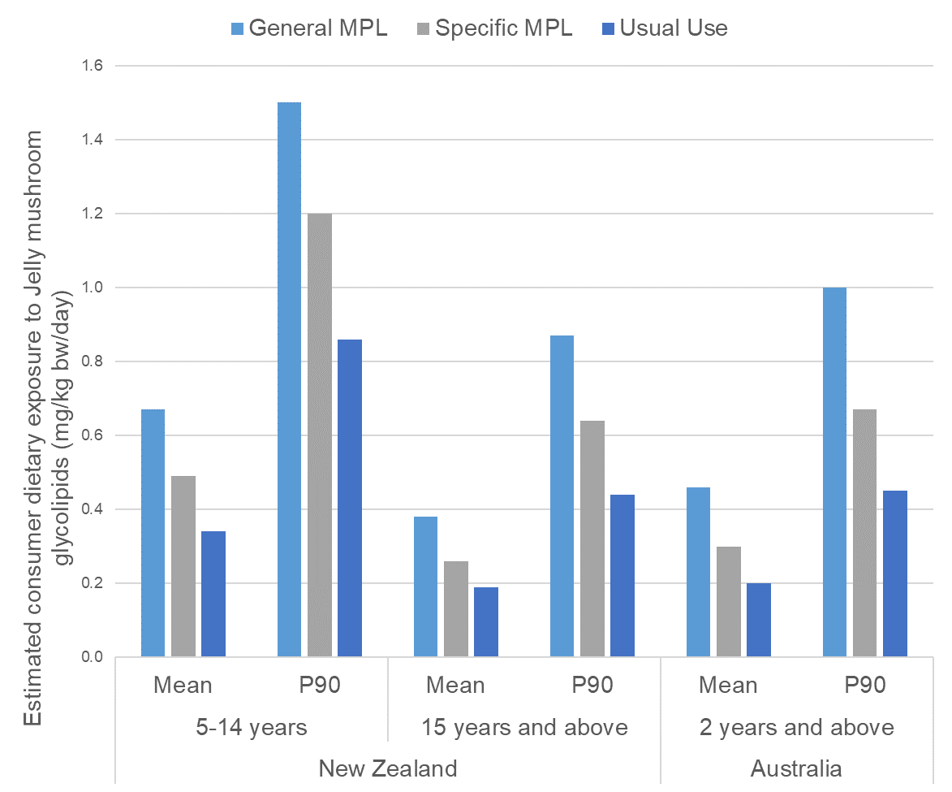
Figure 7 Estimated consumer dietary exposure to jelly mushroom glycolipids for Australian and New Zealand population groups, in mg/kg bw/day

Table 7: Food classes and their contribution to estimated dietary exposures to jelly mushroom glycolipids for Australian and New Zealand population groups
Food code | Food class as requested by Applicant | % contribution
 |  | Australia |  |  | New Zealand
 |  | 2 years and above |  |  | 15 years and above |  |  | 5-14 years
 |  | General MPL | Specific MPL | Usual Use | General MPL | Specific MPL | Usual Use | General MPL | Specific MPL | Usual Use
14.1 | Flavoured mineral water and plant-based milk alternatives | 9 | 14 | 15 | 23 | 33 | 35 | 22 | 31 | 33
14.1.2 | Fruit and vegetable juices | 26 | 41 | 46 | 23 | 33 | 35 | 28 | 39 | 41
14.1.2 | Fruit and vegetable juice products | 18 | 14 | 6 | 10 | 7 | 3 | 9 | 6 | 3
14.1.3 | Water based flavoured drinks, excluding powders, iced teas, brewed soft drinks | 45 | 28 | 31 | 43 | 24 | 26 | 39 | 21 | 23
14.1.3 | Brewed soft drinks | <1 | 1 | <1 | 2 | 2 | <1 | <1 | 2 | <1
14.1.4 | Formulated beverages | <1 | <1 | <1 | <1 | <1 | <1 | <1 | 1 | <1
14.1.5 | Non-brewed soft drinks, iced tea, sold as ready to drink | <1 | <1 | <1 | <1 | <1 | <1 | <1 | <1 | <1
14.1.5 | Pre-packaged ready to drink coffee beverages | <1 | 1 | <1 | <1 | <1 | <1 | 0 | 0 | 0
14.2.1 | Low alcohol beers | 0 | 0 | 0 | <1 | <1 | <1 | 0 | 0 | 0
Note: Major contributing food groups are highlighted in bold.
Based on food consumption data from Day 1 and 2.
Based on food consumption data from Day 1 only.

5.6 Major contributing foods to jelly mushroom glycolipids dietary exposure
Major contributors to dietary exposures are defined as those that contribute ≥5% of the estimated dietary exposure.

The major contributing foods to jelly mushroom glycolipids dietary exposures are consistent across all population groups assessed and all scenarios:
- Water based flavoured drinks, excluding powders, iced teas, brewed soft drinks
- Fruit and vegetable juices
- Flavoured mineral water and plant-based milk alternatives
- Fruit and vegetable juice products.
For the General MPL scenario, Water based flavoured drinks, excluding powders, iced teas and brewed soft drinks is the major contributing food group for all Australian and New Zealand population groups assessed (39 – 45%), followed by Fruit and vegetable juices (23 – 28%). Fruit and vegetable juice products (9 – 18%) and Flavoured mineral waters and plant-based milk alternatives are also major contributors for all population groups assessed (9 – 23%).

For the Specific MPL and Usual Use scenarios, the major contributing food group is Fruit and vegetable juices for all population groups assessed (33 – 41% and 35 – 46%, respectively). Water based flavoured drinks, excluding powders, iced teas and brewed soft drinks, Flavoured mineral waters and plant-based milk alternatives and Fruit and vegetable juice products were also major contributors.

Further details can be found in Table 7 and Figure 8.

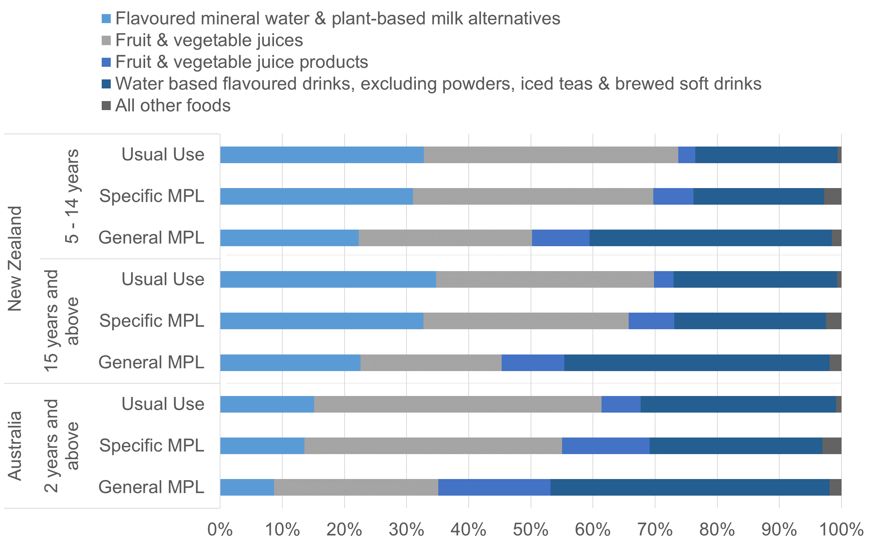
Figure 8 Food categories and their contribution to estimated dietary exposures to jelly mushroom glycolipids for Australian and New Zealand population groups

5.7 Risk Characterisation
FSANZ has established an ADI for jelly mushroom glycolipids of 2.0 mg/kg bw/day. All mean and P90 estimated dietary exposures for all scenarios are below the ADI for all population groups assessed.

The mean and P90 dietary exposures to jelly mushroom glycolipids for Australians aged 2 years and above are 10 – 25% of the ADI and 25 – 50% of the ADI respectively, depending on the scenario.

The mean and P90 dietary exposures were between 15 – 35% and 45 – 75% of the ADI respectively for New Zealanders aged 5-14 years and 9 – 20% and 20 – 45% of the ADI respectively for New Zealanders aged 15 years and above, depending on the scenario.

Table 8: Summary of estimated dietary exposures to jelly mushroom glycolipids from all scenarios assessed for Australian and New Zealander population groups, expressed as %ADI
Estimated consumer dietary exposure (%ADI)
Country | Age group | Consumer to Respondent ratio | General MPL |  | Specific MPL |  | Usual Use
 |  |  | Mean | P90 | Mean | P90 | Mean | P90
New Zealand | 5-14 years | 72.8 | 35 | 75 | 25 | 60 | 15 | 45
 | 15 years and above | 65.5 | 20 | 45 | 15 | 30 | 9 | 20
Australia | 2 years and above | 74.4 | 25 | 50 | 15 | 35 | 10 | 25

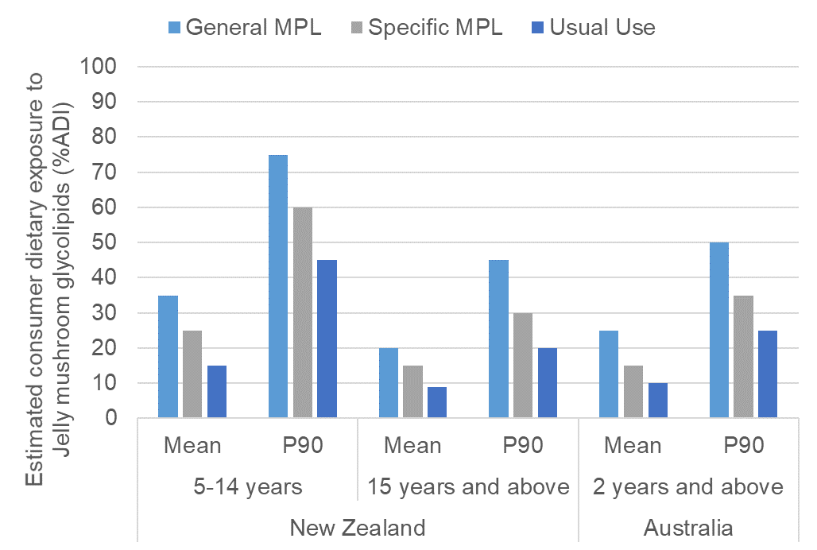
Figure 9 Estimated consumer dietary exposure to jelly mushroom glycolipids for Australian and New Zealand population groups, as %ADI

5.8 Summary of Dietary Exposure Assessment Results
For all of the population groups assessed, New Zealand children aged 5-14 years have the highest mean and P90 dietary exposures to jelly mushroom glycolipids on a body weight basis. Their mean consumer dietary exposures range from 0.34 – 0.67 mg/kg bw/day and P90 exposures from 0.86 – 1.5 mg/kg bw/day, depending on the scenario.

The consumer dietary exposures to jelly mushroom glycolipids for Australians aged 2 years and above (mean: 0.46 mg/kg bw/day; P90: 1.0 mg/kg bw/day) and New Zealander aged 15 years and above (mean: 0.38 mg/kg bw/day; P90: 0.87 mg/kg bw/day) are similar to those estimated for American consumers (mean: 0.51 mg/kg bw/day; P90: 1.09 mg/kg bw/day) in the US GRAS notification (US FDA, 2017).

Across all population groups assessed and all scenarios, the top two major contributing foods to jelly mushroom glycolipids dietary exposures were 1) Water based flavoured drinks, excluding powders, iced teas, brewed soft drinks; and 2) Fruit and vegetable juices.

The mean and P90 estimated dietary exposures for all scenarios and population groups assessed are below the ADI of 2.0 mg/kg bw/day identified by FSANZ, with the mean dietary exposures ranging between 9-35% of the ADI and P90 dietary exposures ranging between 20-75% of the ADI.

6 References
Ao T, Deb CR and Khruomo N (2016). Wild edible mushrooms of Nagaland, India: A potential food resource. Journal of Experimental Biology and Agricultural Sciences DOI: 10.18006/2015.4(1).59.65

ABS (2014) National Nutrition and Physical Activity Survey, 2011–12, Basic CURF. Australian Government, Canberra. Accessed 2 July 2108. http://www.abs.gov.au/AUSSTATS/abs@.nsf/Latestproducts/4324.0.55.002Main%20Features652011-12?opendocument&tabname=Summary&prodno=4324.0.55.002&issue=2011-12&num=&view=
Bitzer, J (2016). Certificate of analysis. IMD Natural Solutions. Germany

Bitzer, J, Henkel T, Nikiforov AI, Rihner MO and Thomas JA (2017a). Pharmacokinetics, excretion balance, and tissue distribution of [14C]-labeled glycolipids and long chain fatty acids from Dacryopinax spathularia in rats. Food and Chemical Toxicology 120: 430-438

Bitzer J, Henkel T, Nikiforov AI, Rihner MO and Leuschner J (2017b). A 90-day oral toxicity study of glycolipids from Dacryopinax spathularia in CD® rats. Food and Chemical Toxicoloogy 109(Pt 1): 569-584

Bitzer J, Henkel T, Nikiforov AI, Rihner MO and Henderson KA (2017c). A 90-day oral toxicity study of glycolipids from Dacryopinax spathularia in Beagle dogs. Food and Chemical Toxicology 109(Pt 1): 544-551

Bitzer J, Henkel T, Nikiforov AI, Rihner MO and Herberth MT (2018). Developmental and reproduction toxicity studies of glycolipids from Dacryopinax spathularia. Food and Chemical Toxicology 120: 430-438

Boa 2004. Wild edible fungi. A global overview of their use and importance to people. Food and Agriculture Organization of the United Nations, Rome, 2004.

Degreef J, Demuynck L, Mukandera A, Nyirandayambaje G, Nzigidahera B and De Kesel A (2016) Wild edible mushrooms, a valuable resource for food security and rural development in Burundi and Rwanda. Biotechnology, Agronomy, Society and Environment 20: 441-452

FSANZ (2009) Principles and Practices of Dietary Exposure Assessment for Food Regulatory Purposes. Report prepared by Food Standards Australia New Zealand, Canberra. http://www.foodstandards.gov.au/science/exposure/documents/Principles%20_%20practices%20exposure%20assessment%202009.pdf
Gamboa-Trujillo P, Wartchow F, Cerón-Martinez C, Andi D, Uwinjin P, Grefa G, Entza M, Chimbo E, Chimbo J, Payaguaje J, Piyaguaje N, Payaguaje D, Licuy V, López V, Mendua M, Criollo M, Jati M, De La Cruz S, Calazacón M, Flores S, Aules E, Aigaje C, De Aro M, Morales A, Murillo Y, Farinango G and Gibertoni T (2019). Edible Mushrooms of Ecuador: consumption, myths and implications for conservation. Ethnobotany Research and Applications 18 http://dx.doi.org/10.32859/era.18.38.1-15

Jappe U, Schwager C, Schromm AB, Roldán NG, Stein K, Heine H and Duda KA (2019). Lipophilic allergens, different modes of allergen-lipid interaction and their impact on asthma and allergy. Frontiers in Immunology 10:22 doi: 10.3389/fimmu.2019.00122

Kulakovskaya TV and Skryabin GK (2003). ATP leakage from yeast cells treated by extracellular glycolipids of Pseudozyma fusiformata. FEMS yeast research 3:401-404

Kumar A, Ali S, Lal SB and Sinha MP (2018). Mycochemical screening and determination of nutritive potency and antioxidant activity of edible macrofungi Dacryopinax spathularia (Schwein) and Schizophyllum commune (Fries). World Journal of Pharmaceutical Research 7: 1311-1321

Kumar , Kumar M and Sinha MP (2019). Hepatoprotective efficacy of edible macrofungi Dacryopinax spathularia (Schwein) and Schizophyllum commune (Fries) against Carbon tetrachloride induced hepatotoxicity in albino Wistar rats. Applied and Natural Science Foundation 11. Doi: https://doi.org/10.31018/jans.v11i1.1959

Lanxess (2018). Summary of efficacy data. IMD Natural Solutions GmbH, Germany

Lanxess (2018a). Stability of Jelly Mushroom Glycolipids (AM-1) in Beverage Applications. IMD Natural Solutions GmbH, Germany

Lee SS, Chang YS and Noraswati MNR (2009). Utilization of macrofungi by some indigenous communities for food and medicine in Peninsular Malaysia. Forest Ecology and Management 257: 2062-2065

Leray, C (2015) Lipids: Nutrition and Health: CRC Press, Taylor & Francis Group. Boca Raton. pp 154–155
Meuninck J (2017). Foraging mushrooms Washington: Finding, Identifying and Preparing Edible Wild Mushrooms. Falcon Guides, Guilford, Connecticut, USA.

Mimee B, Pelletier R and Bélanger RR (2009) In vitro antibacterial activity and antifungal mode of action of flocculosin, a membrane-active cellobiose lipid. Journal of Applied Microbiology 107:989–996

Ministry of Health (2005) 2002 National Children's Nutrition Survey: National Confidentialised Unit Record File (CURF) User Document. Ministry of Health, Wellington

Ministry of Health (2011a) Methodology report for the 2008/09 New Zealand Adult Nutrition Survey. Ministry of Health, Wellington
Ministry of Health (2011b) A focus on nutrition: Key findings of the 2008/09 New Zealand Adult Nutrition Survey. Ministry of Health, Wellington
Onguene AN and Kuyper TW (2019). Wild edible mushrooms depict a dissimilar biogeographical distribution in humid forests of Cameroon. Annual Research and Review in Biology 31:1-13

Sotirova AV, Spasova DI, Galabova DN, E. Karpenko E and Shulga A (2008) Rhamnolipid–biosurfactant permeabilizing effects on Gram-positive and Gram-negative bacterial strains. Current Microbiology 56:639–644
Tribst AA, Sant' Ana A de S; de Massaguer PR (2009) Review: Microbiological quality and safety of fruit juices—past, present and future perspectives. Critical Reviews in Microbiology 35:310–339
US FDA (2017) GRAS Notice (GRN) No. 740: GRAS Notification for Long-Chain Glycolipids from Dacryopinax spathularia. Accessed 3 June 2020. https://www.fda.gov/media/113331/download
Van Dijk H, Onguene NA and Kuyper TW (2003). Knowledge and utilization of edible mushrooms by local populations of the rain forest of South Cameroon. AMBIO: A Journal of the Human Environment 32: 19-23

Zhishu B, Guoyang Z and Taihui L (1993). The MAcrofungus Flora of China’s Guandong Province. The Chinese University Press, Shatin, NT, Hong Kong.

Appendix 1: Dietary Exposure Assessments at FSANZ
A dietary exposure assessment is the process of estimating how much of a food chemical a population, or population sub group, consumes. Dietary exposure to food chemicals is estimated by combining food consumption data with food chemical concentration data. The process of doing this is called ‘dietary modelling’.
Dietary exposure = food chemical concentration x food consumption

FSANZ’s approach to dietary modelling is based on internationally accepted procedures for estimating dietary exposure to food chemicals. Different dietary modelling approaches may be used depending on the assessment, the type of food chemical, the data available and the risk assessment questions to be answered. In the majority of assessments FSANZ uses the food consumption data from each person in the national nutrition surveys to estimate their individual dietary exposure. Population summary statistics such as the mean exposure or a high percentile exposure are derived from the ranked individual person’s exposures from the nutrition survey.

An overview of how dietary exposure assessments are conducted and their place in the FSANZ Risk Analysis Process is provided on the FSANZ website at: http://www.foodstandards.gov.au/science/riskanalysis/Pages/default.aspx
FSANZ has developed a custom-built computer program ‘Harvest’ to calculate dietary exposures. Harvest replaces the program ‘DIAMOND’ that had been used by FSANZ for many years. Harvest has been designed to replicate the calculations that occurred within DIAMOND using a different software package.

Further detailed information on conducting dietary exposure assessments at FSANZ is provided in Principles and Practices of Dietary Exposure Assessment for Food Regulatory Purposes (FSANZ 2009), available at: http://www.foodstandards.gov.au/science/exposure/documents/Principles%20_%20practices%20exposure%20assessment%202009.pdf

A.1.1 How the estimated dietary exposures were calculated
jelly mushroom glycolipids dietary exposures were calculated for each individual respondent in the national nutrition surveys using their individual food consumption records. The Harvest program multiplied the specified concentrations of jelly mushroom glycolipids for an individual food by the amount of the food that an individual consumed in order to estimate the exposure to jelly mushroom glycolipids from each food. Once this had been completed for all of the foods specified to contain jelly mushroom glycolipids the total amount of jelly mushroom glycolipids consumed from all foods was summed for each individual. Where results are expressed on a body weight basis, each individuals body weight was used. Mean and 90th percentile (P90) exposures were then derived from the individuals’ ranked exposures. Estimated dietary exposures for the population on a body weight basis were compared to the Acceptable Daily Intake (ADI) for risk characterisation purposes.

A1.2 Food consumption data used
The most recent food consumption data available were used to estimate dietary exposures to jelly mushroom glycolipids for the Australian and New Zealand populations. The national nutrition survey data used for these assessments were:
- The 2011-12 Australian National Nutrition and Physical Activity Survey (2011-12 NNPAS)
- The 2002 New Zealand National Children’s Nutrition Survey (2002 NZ CNS)
- The 2008-09 New Zealand Adult Nutrition Survey (2008 NZ ANS).

The design of each of these surveys varies somewhat and key attributes of each are set out below. Further information on the national nutrition surveys used to conduct dietary exposure assessments is available on the FSANZ website at http://www.foodstandards.gov.au/science/exposure/Pages/dietaryexposureandin4438.aspx.

A1.2.1 2011–12 Australian National Nutrition and Physical Activity Survey (2011-12 NNPAS)
The 2011–12 Australian National Nutrition and Physical Activity Survey (2011-12 NNPAS), undertaken by the Australian Bureau of Statistics, is the most recent food consumption data for Australia. This survey includes dietary patterns of a sample of 12,153 Australians aged from 2 years and above. The survey used a 24-hour recall method for all respondents, with 64% of respondents also completing a second 24-hour recall on a second, non-consecutive day. The data were collected from May 2011 to June 2012 (with no enumeration between August and September 2011 due to the Census). Only those respondents who had two days of food consumption data (excluding dietary supplements) were used to estimate jelly mushroom glycolipids dietary exposures for this assessment. The Day 1 and 2 average provides the best estimates of jelly mushroom glycolipids dietary exposures for Australians aged 2 years and above. Consumption and respondent data from the survey were incorporated into the Harvest program from the Confidentialised Unit Record Files (CURF) data set (ABS 2014). These data were weighted during the calculations undertaken in Harvest.

A1.2.2 2002 New Zealand National Children’s Nutrition Survey (2002 NZ CNS)
The 2002 NZ CNS (Ministry of Health, 2005) was a cross-sectional and nationally representative survey of 3,275 New Zealand children aged 5–14 years. The data were collected during the school year from February to December 2002. The survey used a 24-hour food recall and provided information on food and nutrient intakes, eating patterns, frequently eaten foods, physical activity patterns, dental health, anthropometric measures and nutrition-related clinical measures. It was also the first children’s nutrition survey in New Zealand to include a second day diet recall data for about 15% of the respondents, and dietary intake from both foods (including beverages) and dietary supplements. Only the Day 1 24-hour recall data for all respondents (excluding supplements) were used for this assessment. These data were weighted during the calculations undertaken in Harvest.

A1.2.3 2008-09 New Zealand Adult Nutrition Survey (2008 NZ ANS)
The 2008 NZ ANS (Ministry of Health 2011a; Ministry of Health 2011b) provides comprehensive information on the dietary patterns of a sample of 4,721 respondents aged 15 years and above. The survey was conducted on a stratified sample over a 12-month period from October 2008 to October 2009. The survey used a 24-hour recall methodology with 25% of respondents also completing a second 24-hour recall. The information collected in the 2008 NZ ANS included food and nutrient intakes, dietary supplement use, socio-demographics, nutrition related health, and anthropometric measures. Only the Day 1 24-hour recall data for all respondents (excluding supplements) were used for this assessment. These data were weighted during the calculations undertaken in Harvest.

A1.3 Assumptions and limitations of the dietary exposure assessment
The aim of the dietary exposure assessment was to make the most realistic estimation of dietary exposures to jelly mushroom glycolipids as possible. However, where significant uncertainties in the data existed, conservative assumptions were generally used to ensure that the estimated dietary exposure was not an underestimate of exposure.

Assumptions made in the dietary exposure assessment include:
- Unless otherwise specified, all foods within a category contain jelly mushroom glycolipids at the concentrations listed in Error! Reference source not found..
- The request for addition of jelly mushroom glycolipids to ‘Water based flavoured drinks’ (14.1.3) does not include the addition to powders. Iced teas and brewed soft drinks are considered separately as they have different proposed concentrations.
- The request for addition of jelly mushroom glycolipids to the entirety of food category 14.1 (non-alcoholic beverages) includes mineral waters with flavourings and other additions, however excludes plain mineral waters including bottled/packaged water.
- The request for the addition of jelly mushroom glycolipids to ‘Coffee, coffee substitutes, tea, herbal infusions and similar products’ (14.1.5) includes only pre-packaged ready to drink varieties. All coffees, teas and similar products made directly from powder, grounds, leaf and pre-mixes that are then immediately consumed are excluded from this category (e.g. coffee shop beverages that are made to order; homemade teas and coffees etc.).
- National Nutrition Surveys did not contain readily identifiable pre-packaged ready to drink coffees therefore it is assumed that coffee flavoured milk consumption is a suitable proxy for these products.
- Since the application only relates to non-alcoholic beverages, it does not include beer, wine, spirits and related products unless it is a non-alcoholic product.
- While the application did not specifically discuss plant-based milk alternatives and coconut milk/cream (e.g. as used to cook curries) these have been included in the assessment.
In addition to the specific assumptions made in relation to this dietary exposure assessment, there are a number of limitations associated with the nutrition surveys from which the food consumption data used for the assessment are based. A discussion of these limitations is included in Section 6 of the Principles and Practices of Dietary Exposure Assessment for Food Regulatory Purposes (FSANZ 2009).

Dietary exposure assessments based on 2011-12 NNPAS, 2002 NZ CNS and 2008 NZ ANS food consumption data provide the best estimation of actual consumption of a food and the resulting estimated dietary exposure assessment for the Australian population aged 2 years and above, as well as the New Zealand populations aged 5–14 years and 15 years and above, respectively. However, it should be noted that NNS data do have limitations. Further details of the limitations relating to dietary exposure assessments undertaken by FSANZ are set out in the FSANZ document, Principles and Practices of Dietary Exposure Assessment for Food Regulatory Purposes (FSANZ 2009).

Harvest is FSANZ’s custom-built dietary modelling program that replaced the previous program, DIAMOND, which does the same calculations just using a different software program.

